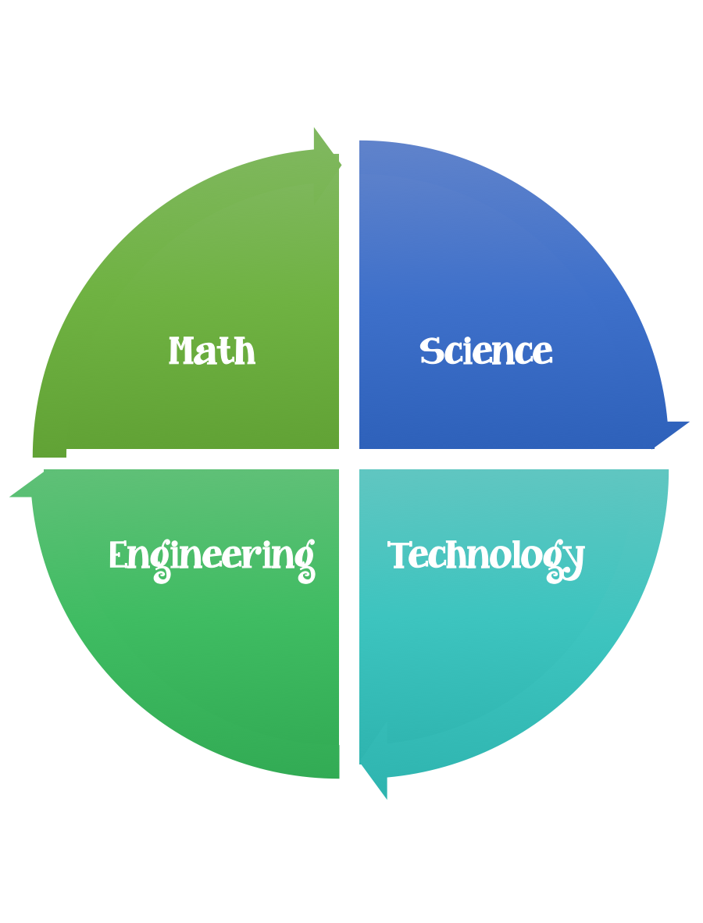
Findley Oaks STEM Connect
1st Grade Design Brief

Month  August | Challenge  Tin Foil People | Unit  Light and Shadows
Standard:
Students should follow the engineering design process.
Background/Problem: The kindergarten classes at Findlay Oaks Elementary need help learning about shadows. They would like the first graders to put together a stop motion video to help explain this concept. Can you help?
Design Challenge: Students will design a figurine out of tin foil that has flat feet and attach it to a piece of tag board. The students will need to be able to explain where the shadow can be found in the morning, noon, and afternoon, then take still shots and create a stop motion video. The shadows will be measured and then compared to each other.
Criteria: Each figurine needs to be made out of 4 6x6 pieces of tinfoil. The figurine need to have a head, two arms, a body, and two legs. The figure must be able to stand up. (Flat Feet)

Constraints: Be careful with your tin foil-that is all you get. The figurine must be at least 5 unifix cubes tall and be able to stand up without falling over. You will have 30 minutes to complete this build.
Materials: (Per groups of 2)
- 4 pieces of 6x6 heavy duty tin foil Advanced students should measure and cut this themselves.
- 6x6 pieces of heavy cardboard or tag board.

Tools:
Glue
Rulers
Flashlight
Paper
Pencils
IPads

Students will use their IPads to create their stop motion videos.
Make sure they have a plan before they begin their build.

