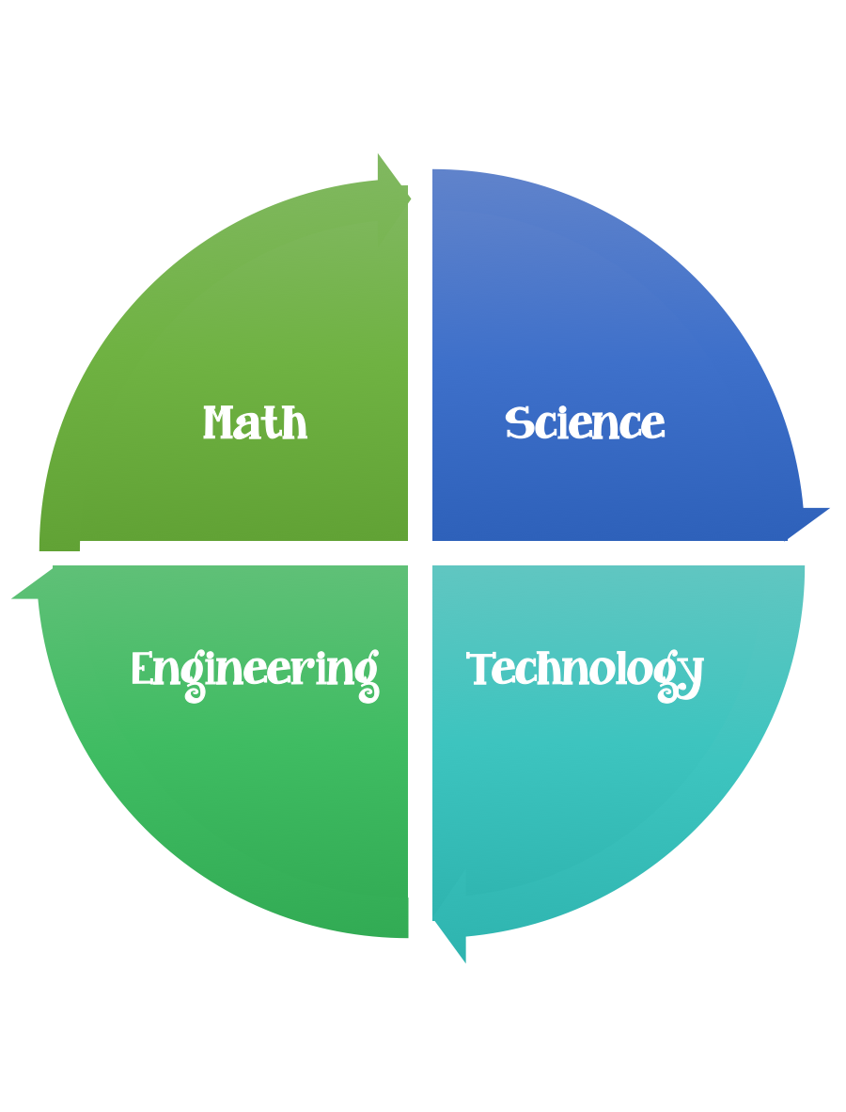
Findley Oaks STEM Connect
1st Grade Design Brief

Month  November | Challenge  Changing Seasons Paper Dolls | Unit  Weather  Patterns
Standard:
Students should follow the Engineering Design Process.
Background/Problem: We have been learning about the four seasons - winter, spring, summer, and fall. We learned that we wear different clothing depending on the season and the weather.
Design Challenge: Working with a partner and using the materials and tools provided, design and create one free-standing paper doll with a lever operated moving part and four outfits. One for each of the four seasons that will stay on the paper doll with out falling off. Observers must be able to name the season your doll is dressed for without being told.
Criteria:
Your paper doll must:
- Be free standing.
- Have a lever operated moving part.
- Have four outfits, one for each of the four seasons.
- The four outfits must stay on without falling off.

- Observers must be able to name the season your doll is dressed for without being told.

Constraints: You can only use the materials provided.
Materials: (per group of 2)
Cardboard
Cardstock
Construction paper 1 new
Paper in the scrap box
Pipe cleaners
Craft sticks
Twist ties
Rubber bands
Ribbon
2 paper fasteners
Fabric scraps

Tools:
Glue
Markers and / or crayons
Scissors
Crazy scissors
Hole punch

Paper (For design planning)
Pencils

Options – have the students pick their favorite season and make one set of clothing. Have each group make a boy and a girl.

