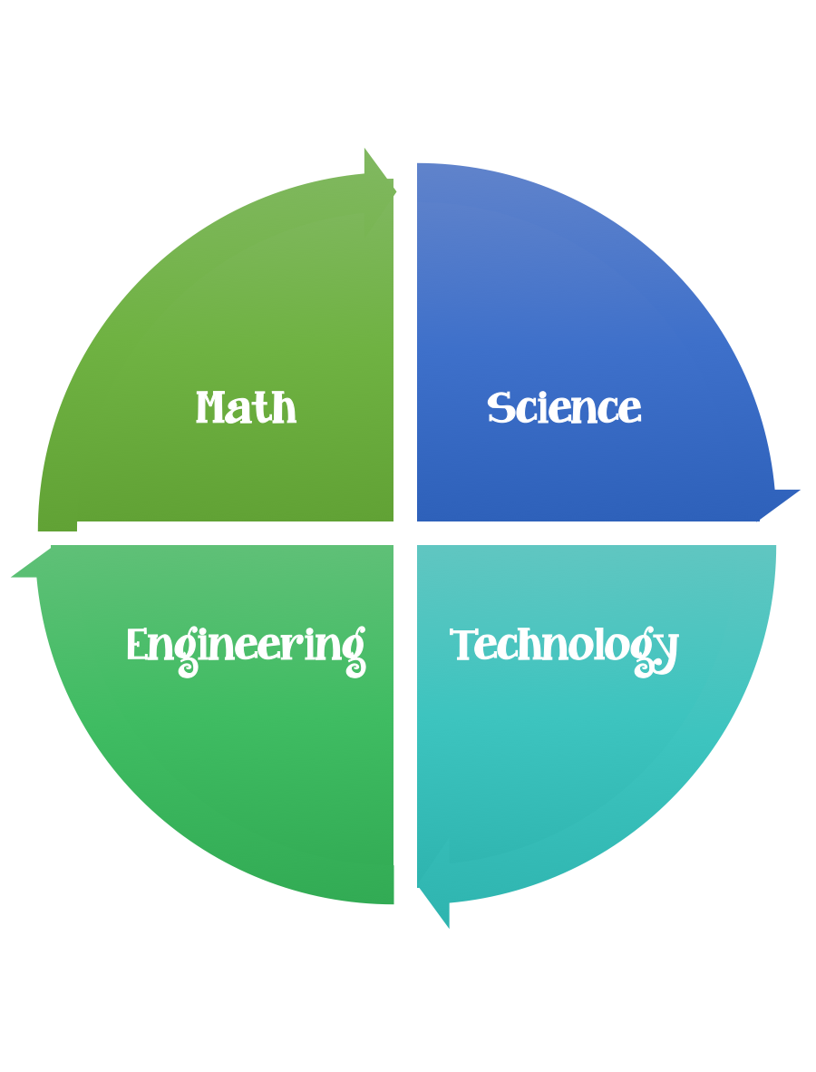
Findley Oaks STEM Connect
2nd Grade Design Brief

Month  August | Challenge  Pop Rockets | Unit  Physical Attributes of Stars
Standard:
Students should follow the Engineering Design Process.
Background/Problem: We have been learning about the stars and the sun. Wouldn’t it be fun to travel in a rocket to get a closer look. What is a star? Let’s review the attributes that we have been learning about. NASA needs your help designing a rocket to explore the stars with. Can you help?
Design Challenge: Your challenge is to create/design a pop rocket that we can pretend to get a closer look at the stars and explore them for NASA.
Criteria:
Your rockets must:
- be decorated.
- have a name.
- have on attribute of a star written on it.

Constraints: You can only use the materials provided. Everyone in your group needs to participate. (Remember that this science experiment uses antacids which can contain aspirin so that normally we should not play with these without an adult.) Teachers –make sure that you clean up all of the remaining bits of tablets.

Each student should launch their rocket twice and predict how far /high it will travel.

Materials: (per person) (teacher discretion, students could work in pairs or groups)
Mini M&M tubes (empty with the labels removed and the tab that holds the top on completely cut off.)
Antacid tablets
Cardboard – cereal boxes work great Used to make the mini cones for the tope of the rockets. (can be made ahead)
Heavy duty aluminum foil
Decorations (asst. stickers)
Washi tape – decorative colors
Painters tape
Clay – small ball each –to put under the lid the hold the tablet in place.
Water bottle (each student will need to measure 1 teaspoon of water)

Tools:
Glue--- Glue gun – teacher/parent assisted
Markers and / or crayons
Scissors
Crazy scissors
Hole punch
teaspoons
Meter sticks

Paper (For design planning)
Pencils

The canisters are decorated – the cones are covered in aluminum foil and then attached to the bottom of the canister (the side opposite the cap with the not glue gun)

Each student under assistance will need to measure and pour 1 teaspoon of water into the rocket and then attach the top/lid. Once the lid has been placed snugly on the rocket,

flip it over onto a wooden board (placed outside on the grass) and run for cover.

The Science Behind It
When water and antacid mix, carbon dioxide gas is produced. By placing the lid on the rocket, you are trapping those gas bubbles inside. As more and more bubbles are produced, the pressure inside the rocket builds, creating enough force to break the seal on the lid. There is so much force from the built up pressure that it launches the rocket into the air.

