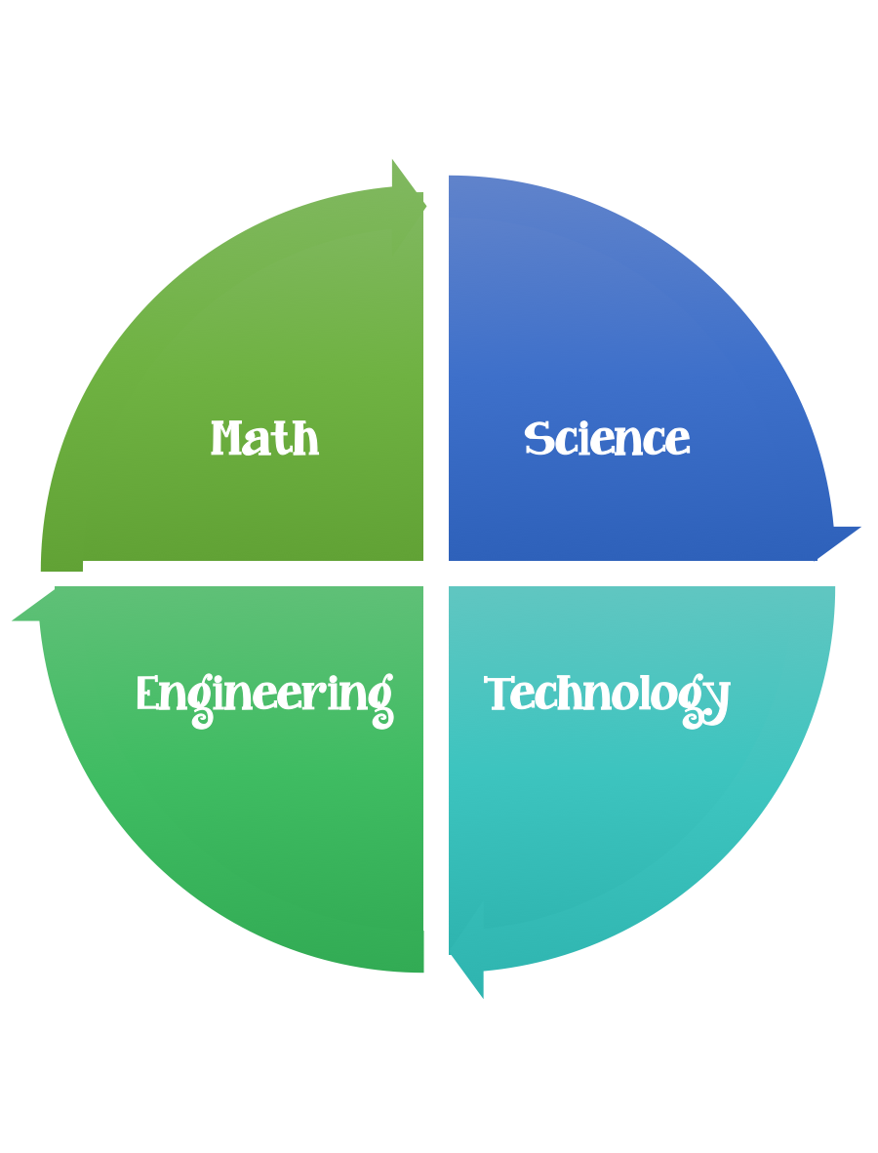
Findley Oaks STEM Connect
2nd Grade Design Brief

Month  February | Challenge  Operation Top Secret  Message | Unit  Pushes and Pulls
Standard:
Students should follow the Engineering Design Process.
Background/Problem:
Powerpoint
Click on the link to download the PowerPoint

Design Challenge: Your challenge is to relay a “Top Secret Message” to the wonderful Princess Reagan who is trapped on the balcony of the EDP Tower.
Criteria: Your contraption needs to:
- be able to deliver a message to the princess.
- have a moving part.
- be as tall as possible.
- be free standing and portable.

Constraints:
All members of your team must participate
You can use some of are all of the materials.

Materials: (per team or group) 2,3, or 4 (teacher discretion)
- 10 pieces of paper
- 10 paper clips
- 10 rubber bands
- 20 feet of string
- 3 feet of masking tape

Tools:
Rulers
scissors
Paper/pencil for design planning

