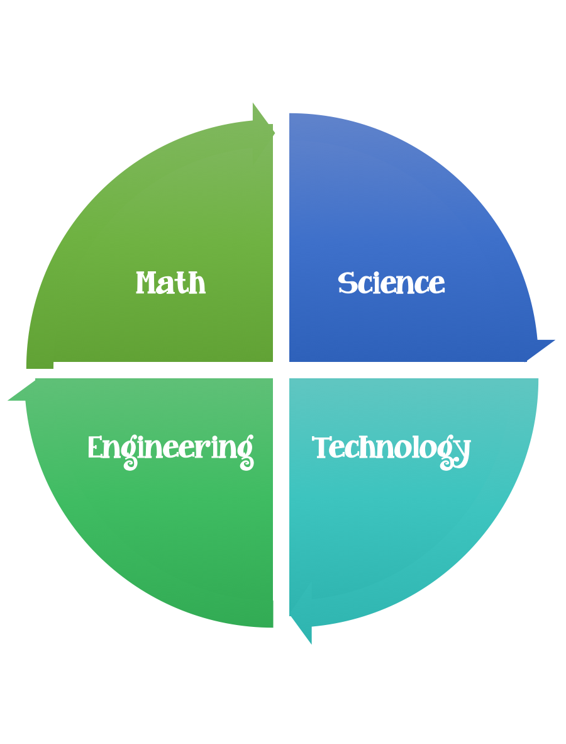
Findley Oaks STEM Connect
2nd Grade Design Brief

Month  October | Challenge  Seasons Tree | Unit  Causes of Change
Standard:
Students should follow the Engineering Design Process.
Background/Problem: Winter, spring, summer, and fall. What happens to a tree during these four seasons? Your teacher needs your help making a presentation to demonstrate these changes to other students in the school.
Design Challenge: Your challenge is to create/design a tree that represents a season and is free standing. The tree should have a form of participation and/or other element that matches the season of the tree. (raindrops, snowflakes, buds, or fruit)
Criteria:
Your tree must:
- be free standing. (can not be attached to the table- must be able to be moved).
- represent one of the four seasons.
- have one attribute that relates to the season.
- be three dimensional.
- have a trunk.
- have at least three branches.
- be taller than 5 unifix cubes and shorter that 12.

Constraints: You can only use the materials provided. Everyone in your group needs to participate.
Materials: (groups of 2, 3, or 4)) (teacher discretion)
12x12 piece of brown bulletin board paper (some students may be able to measure this themselves) or brown lunch bags.
felt (pink, white, light blue)
construction paper (use scraps from scrap box when possible)
10 centimeters of tape
yarn (brown and green)
Anything else your teacher gives you.

Tools:
Markers and / or crayons
Scissors
Crazy scissors
Hole punch
Unifix cubes
Ruler

Paper (For design planning)
Pencils

Option: Make a list of the attributes of your seasonal tree and be able to explain/share with your class.

