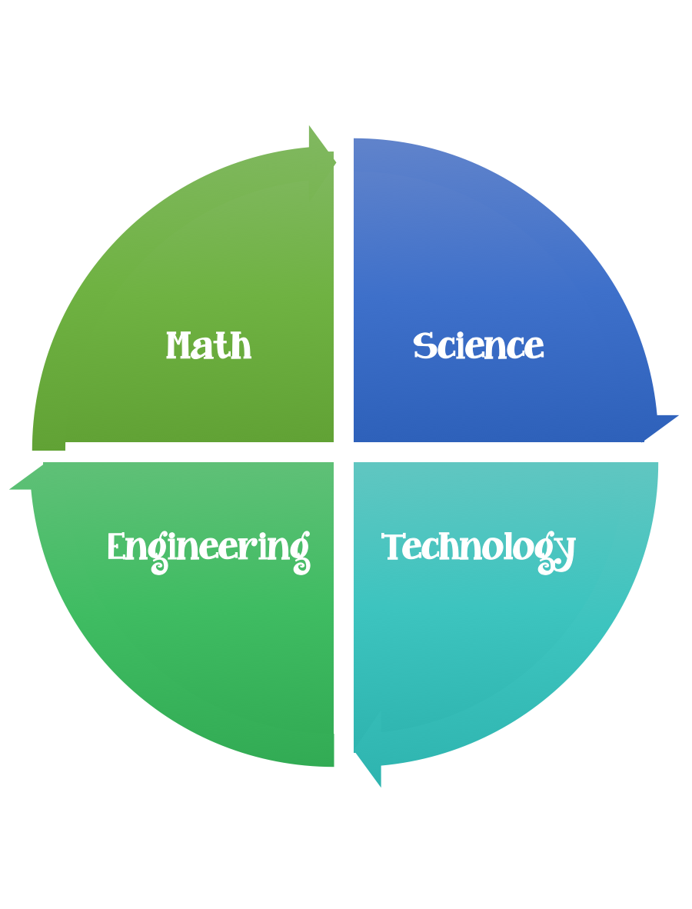
Findley Oaks STEM Connect
3rd Grade Design Brief

Month  March | Challenge  Invisible  Forces | Unit  Magnets
Standard:
Students should follow the Engineering Design Process.
Background/Problem: To change a spacecraft's speed and direction, NASA engineers use a planet's or moon's gravity, a process called a "gravity assist." In this video from Design Squad Nation, kids design and build systems that use magnets to control the speed and direction of a rolling ball. As they build their systems, the kids use the engineering design process, apply a variety of science concepts (e.g., force, magnetic fields, inverse square law), and learn how NASA spacecraft use gravity to help them explore the solar system.
Click Here For Design Squad Activity
Design Challenge:
Criteria:
Constraints:
You must work with a partner (or in a group of 3) teacher discretion.
Make sure you have a design plan before you start

Materials: (per team or group) 2,3 (teacher discretion)
Paper cup (6- to 8-ounce)
• Strip of index card (2.5 x 12.5 centimeters) [1 X 5 inches])
• 30-centimeter (12-inch) length of flexible rope (e.g., clothesline)
• 1 steel ball (e.g., 60-millimeter [quarter inch] ball bearing)
• 1 strong magnet
• 1 target (e.g., “X” of tape on the table or an object to hit)
• Tape (any kind)

Tools:
Scissors
Crazy scissors
Staplers
Hole punch
Rulers

Paper/pencil for design planning

Options: Brainstorm ideas…. make sure the students have time to plan.
Use design brief below.

