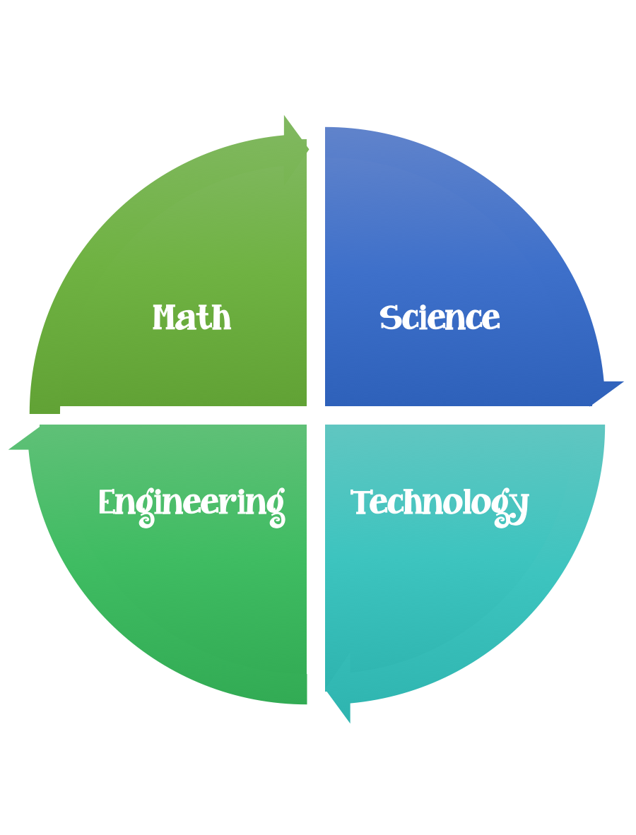

**Findley Oaks STEM Connect**

**3rd Grade Design Brief**

|  |  |  |
| --- | --- | --- |
| **Month**  **November** | **Challenge**  Reusable Object Project | **Unit**  Pollution and Conservation |

**Standard:**

Students should follow the **Engineering Design Process.**

**Background/Problem:** **We have learned that it is a good idea to conserve the resources/things that we have. Recycle, reuse, and reduce.**

**Design Challenge:** Your design challenge is to make some something that is useful/usable out of recyclable materials.

**Criteria: Your creation must:**

* **be useable and useful.**
* **be strong, sturdy, and stable.**

Constraints:

You must work with a partner (or in a group of 3) teacher discretion.

Make sure you have a design plan before you start.

Materials: (per team or group) 2,3 (teacher discretion)

Have the students bring in recyclable items.

String

Tape

Tools:

Scissors

Crazy scissors

Staplers

Hole punch

Rulers

Paper/pencil for design planning

Options: Brainstorm ideas…. make sure the students have time to plan.

Use design brief below.





