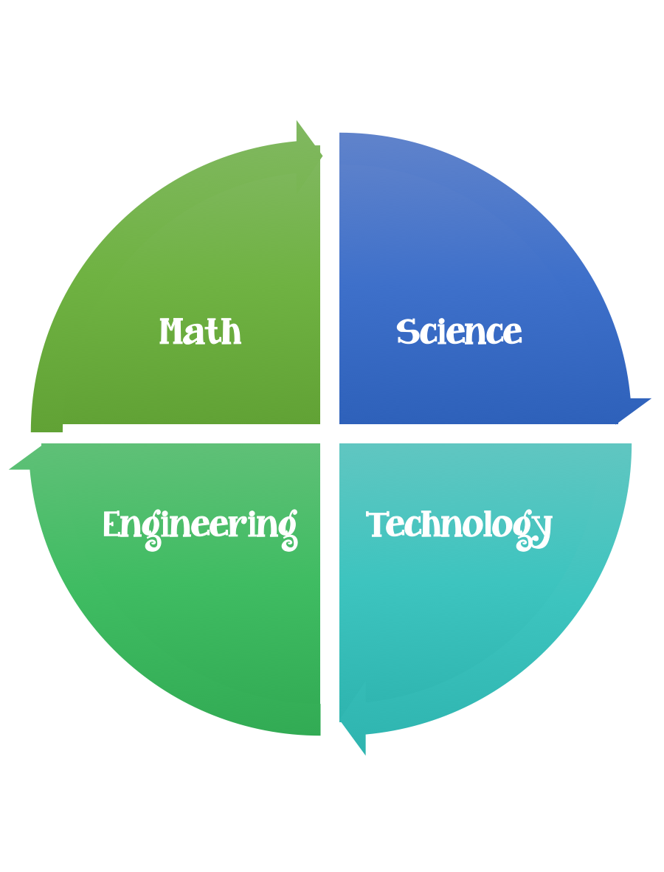
Findley Oaks STEM Connect
3rd Grade Design Brief

Month  September | Challenge  Mining Resources | Unit  Pollution and Conservation
Standard:
Students should follow the Engineering Design Process.
Background/Problem: Some of the resources we use are found underground. To reach valuable rocks and minerals, people dig mines. In Georgia, we mine for kaolin (a type of clay) which we use for making paper. However, mining can impact the environment around it. Investigate to find out more.
Design Challenge: Your design challenge is to remove all of the chocolate chips from a cookie with as little damage as possible. (Mine the resources from the land with as little damage as possible). Estimate how many chocolate chips you might find before you begin.
Criteria: Your cookie must:
- be mined very carefully, with as little damage as possible to the cookie.
- Limited to two cookies per group (one for testing, one for the redesign).
- You may not eat the cookie or the chocolate chips.

Constraints:
You may only use your deigned tool to extract the chocolate chops or raisins (no hands allowed).
You must work with a partner (or in a group of 3) teacher discretion.

Materials: (per team or group) 2,3 (teacher discretion)
Chocolate Chip Cookies (2 per group/team)

Tools:
Small cup of water with dropper
Paper plate
Toothpick
Paperclip

Paper/pencil for design planning

Options: Oatmeal raisin cookies may be used if there are food allergies.

