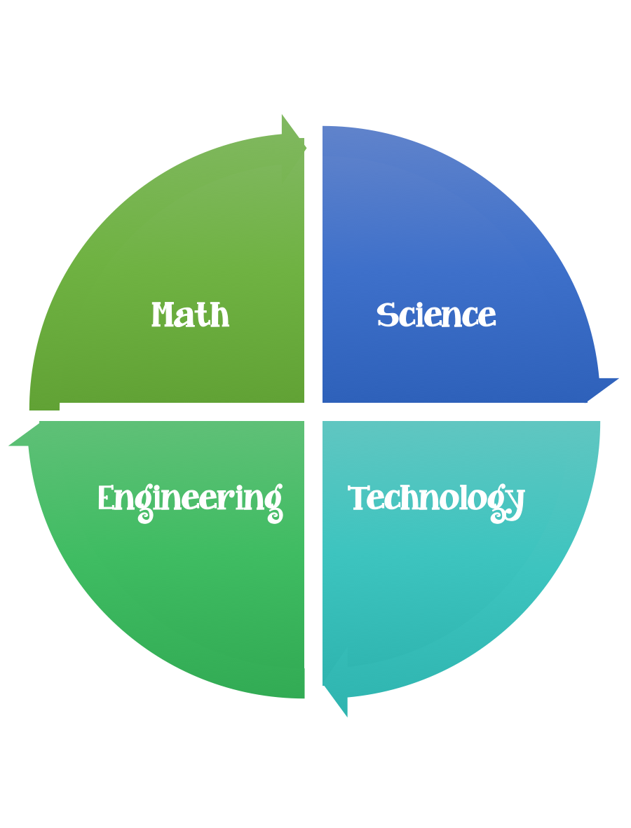
Findley Oaks STEM Connect
4th Grade Design Brief

Month  April | Classroom Camouflage | Unit  Survival and Extinction of Organisms
Standard:
Students should follow the Engineering Design Process.
Background/Problem: Review the concept of camouflage as an animal adaptation. Explain that many animals have colors or markings on their fur, feathers, scales or skin that enables them to blend in with their habitat (the place where that animal lives). Ask the students how camouflage helps an animal survive. Ask for examples (a motionless green frog at the edge of a pond; drab brown feathers on most incubating female birds; winter white/summer brown colors of the arctic fox and ptarmigan, etc.).

Design Challenge: Students will demonstrate their understanding of camouflage by designing a snake, butterfly, or iguana that blends into the classroom "habitat."

Criteria: Your animal must:
- be either a snake, butterfly. or iguana.
- hidden in the pretend wild habitat classroom; select a specific home.
- be colored with markers, crayons, or colored pencil so that it will be camouflaged in the habitat selected.
- be placed in their habitat without burying them. They must be open, hidden only by their coloring and patterns

Constraints:
You must work individually or with a partner - teacher discretion.
Make sure you have a design plan before you start.
You may use some or all of the materials listed.

Materials: (per person) 2,3, or 4 (teacher discretion)
- Paper snake or butterfly patterns for each student

Tools:
- Markers
- Crayons
- Colored Pencils
- Clear Tape
Paper and pencils to plan.

Options: Brainstorm ideas…. make sure the students have time to plan.

EXTENSION
Sometimes an animals coloring or pattern does the opposite of camouflage. Instead, its markings or colors call attention to the animal. Colors may issue a warning to other species, or may attract members of the opposite sex of the same species (the bright colors of the South American arrow poison frog; the bright showy feathers of the male peacock).
Repeat the Classroom Camouflage activity by having students’ animals that do not blend in with their surroundings. Since they can't hide, how might they protect themselves from predators? What are some of the advantages and disadvantages of camouflage compared to advertising or warning coloration?

