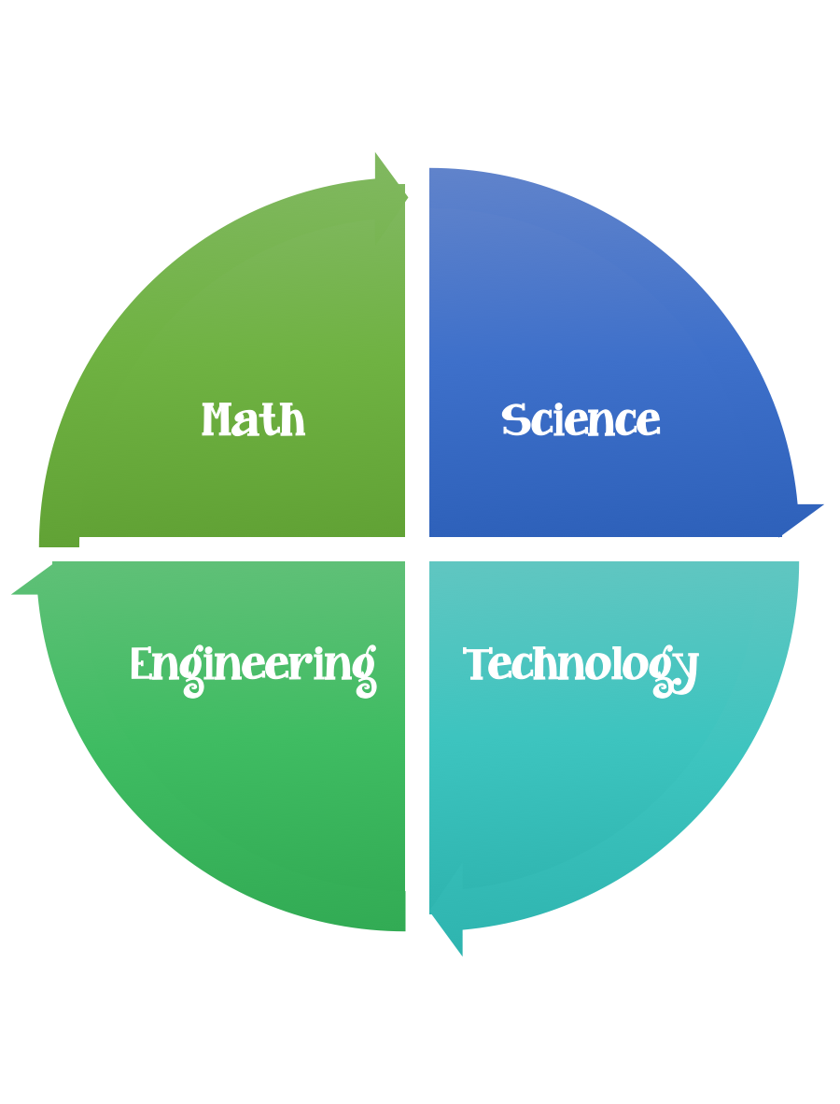
Findley Oaks STEM Connect
4th Grade Design Brief

Month  February | Air Powered Car | Unit  Forces and Motion
Standard:
Students should follow the Engineering Design Process.
Background/Problem: The Johns Creek Toy company needs a prototype for a new toy they are developing. They would like a toy car that runs on air-pressure and travels at least 3 meters. Design and build a car to meet prescribed criteria.
Design Challenge: Students will demonstrate their understanding of forces and motion by designing an air powered car.
Criteria: Your car must:
- Car is made of recycled materials
- Car uses air-pressure to move
- Car travels at least 3 meters

Constraints:
- You must work individually or with a partner - teacher discretion.
- Make sure you have a design plan before you start.
- You must budget your money – your team has 20 dollars to spend. No exchanges for returns
- Your team has 45 minutes to complete this challenge.

Materials: (per person) 2,3, or 4 (teacher discretion)
Toilet Paper Tube $1
Paper Towel Tube $1
1 meter of masking tape $5
Cereal Box / Tissue Box $5
Craft Stick $1
Toothpicks (10) $1
Balloon * $1
Construction Paper $1 per sheet
1 Meter of string $4
Bottle of Glue $5
Pipe Cleaner $3
Paper plate / bowl $1
CD $2 ea.
Bottle Caps $1 ea.
Water Bottle $5

Tools:
- Markers
- Crayons
- Colored Pencils
- Planning and Reflection Sheets
- Meter Sticks

Paper and pencils to plan.

Options: Brainstorm ideas…. make sure the students have time to plan.

