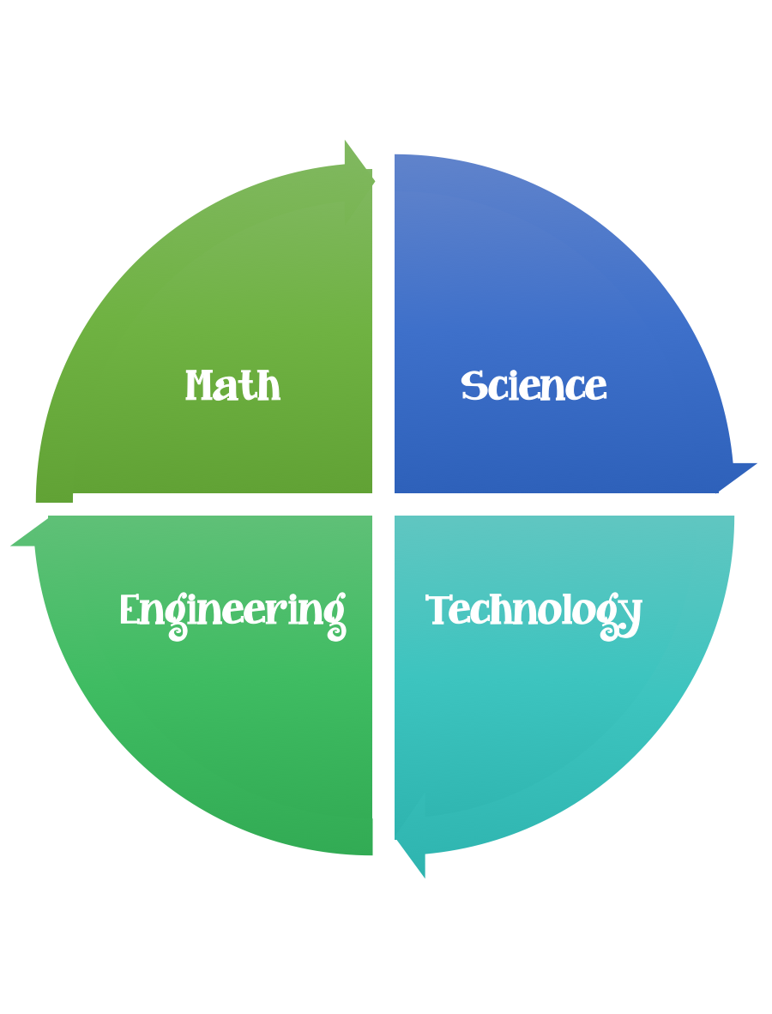
Findley Oaks STEM Connect
4th Grade Design Brief

Month  September | Challenge  Blowing in the Wind | Unit  Weather
Standard:
Students should follow the Engineering Design Process.
Background/Problem: In our science unit on weather , we have been studying wind and how it affects weather changes across our country. We have learned how wind creates fronts, high and low pressure systems, hurricanes and tornadoes. We have also studied the different types of instruments used to measure wind speed and direction, like anemometers, wind vanes, and wind socks. We’re going to put our knowledge to use by creating a weather station outside our school.
Design Challenge: Your challenge is to design a windsock that can detect wind direction and speed when placed in our weather station.
Criteria: Your windsock must:
- be weather proof.
- move freely around pole.
- stand up to winds around 10 MPH.
- correctly identify wind direction when tested on five different days.
- maintain attractive colorful appearance for more than one week outdoor.

Constraints:
You must work with a partner (or in a group of 3) teacher discretion.
Make sure you have a design plan before you start.
You may use some or all of the materials listed.

Materials: (per team or group) 2,3 (teacher discretion)
Construction paper
Fabric strips
Trash bags
Dry cleaner bags
Tissue paper
Crepe paper
String
Yarn
Paper clips
Pipe cleaners
Wire bag ties
Thread
Glue
Washers
12 inches’ tape

Tools:
Scissors
Crazy scissors
Staplers
Hole punch
Rulers

Paper/pencil for design planning

Options: Brainstorm ideas…. make sure the students have time to plan.

