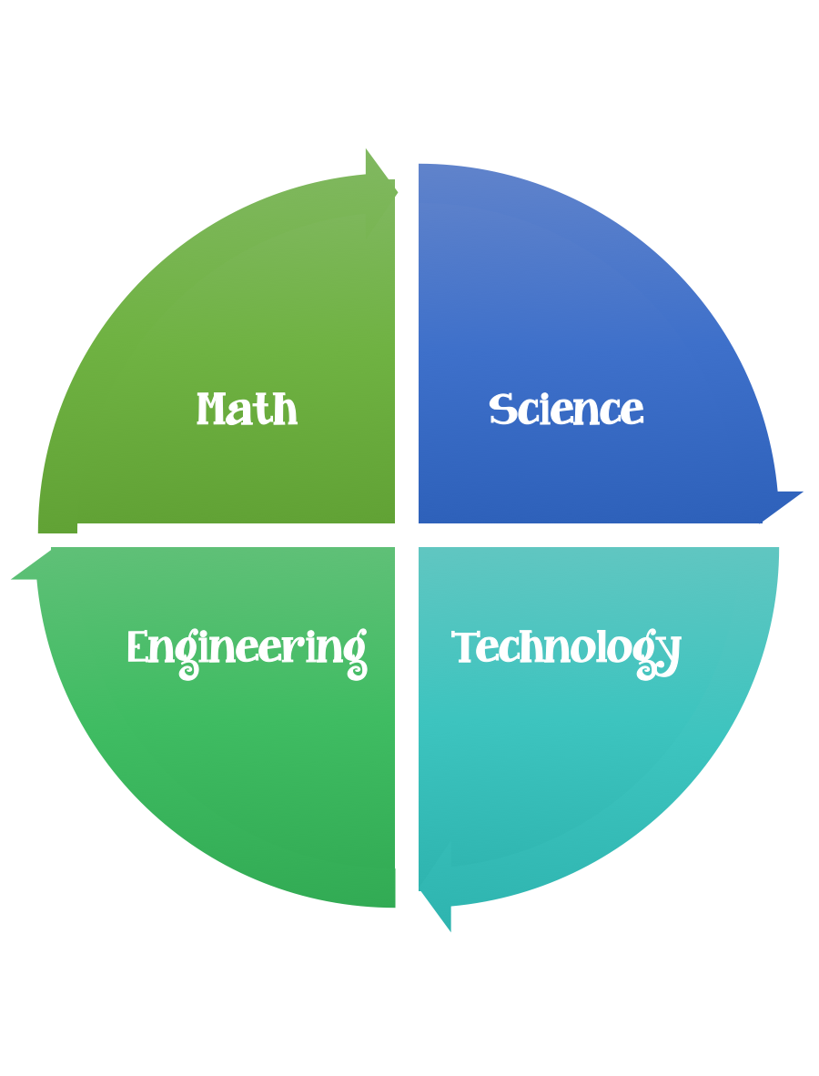
Fulton County STEM Connect
Kindergarten Design Brief

Month  April | Challenge  Jack and the Beanstalk  Bean Balance | Unit  Plants
Standard:
Students should follow the engineering design process.
Background/Problem: Watch the you tube video about Jackie and the Beanstalk on your iPad or together as a class. Jackie and the Beanstalk
Ask the class questions about the story. Would you trade your cow for magic beans? Would you have climbed up the beanstalk? Why did the beanstalk grow so fast? What does a plant need to grow? It probably would be hard to climb up a beanstalk, you would need to have good balance. Jackie needs help learning to balance. Can you help her learn how to balance?
Design Challenge: Create a beanstalk out of a paper plate and a paper towel role. Then, see how many beans you can balance on top.
Criteria: Your beanstalk needs to be at least 15 unifix cubes tall. The plate should be attached onto the top of the paper towel role.

Constraints:

Constraints:
- Use only the materials provided.
- Do not tape the beanstalk to the table.
- If the beans fall off you must start the process over.
- You will have 5 tries to place as many beans on top as you can. Use tally marks to keep track.
- Out of the five tries, pick the one that had the most balanced beans.
- The beans that you were able to balance you need to weigh using a balance. The student with the most weight will meet the challenge.
(How to use a balance and what a gram is will need to be explained to the students).

Options: Brainstorm what worked and what didn’t. What would you do better next time? How did your group work together?
Can you count the beans in groups of 2? In groups of 5? In groups of 10?
Paint the beanstalk green.
Make a graph of the classroom total number of balance beans.

Materials: (per student or group) teacher choice
paper towel rolls
6 in. paper plates
lima beans or any other bean. 20-30 per group
20 centimeters of masking tape
Tools:
Scissors
Markers
Rulers
Option: paint
Balance Scales

Pencil and pencil (For planning)

