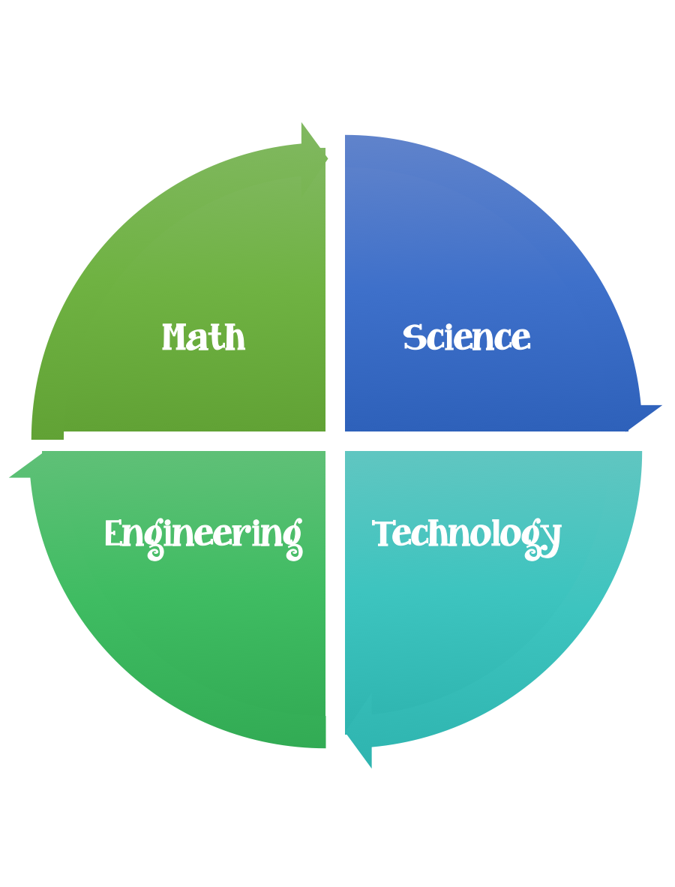
Findley Oaks STEM Connect
STEM Classroom Coordinator

Teacher __________________________
As the STEM Connect Classroom Coordinator your responsibility will be to assist the teacher in accumulating the supplies needed for the classroom STEM Challenges.
Suggested Resources:
Parent donations
Business Partner donations
Saving recycled items

If you are interested in this volunteer position, please sign-up below.

- _____________________________________
Alternates:
- _____________________________________
- _____________________________________
- _____________________________________
- _____________________________________

Teachers – please make a copy and return to Sharon Ferguson

