Findley Oaks STEM Connect
1st Grade Design Brief

Month  April | Challenge  Grass Head  Recyclable Materials | Unit  Plants
Standard:
Students should follow the Engineering Design Process.
Background/Problem: Do you remember what plants need to grow? Let’s make a list.
Our classroom needs some sprucing up. Your teacher needs your help. Can you make a few grass heads to help decorate the room?
Design Challenge: Design and make your own grass head.

Criteria:
Your grass head must:
- have a nose, mouth, and two eyes.
- be dressed.
- be either a boy or girl.
- have an accessory.

Constraints: You can only use the materials provided. Everyone in your group needs to participate.

Materials: (per group of 2)
You will need:
- Old nylon stockings or pantyhose. Knee highs and pop socks, work great. You can also use regular old socks, but the grass sometimes has trouble poking through.
- Grass seeds. I bought a small "lawn repair kit" which has seeds pre-mixed with slow release fertilizer, but you can use whatever seeds you've got handy. I hear that chives, rye or alfalfa seeds also work well.

- Sawdust or potting mix for stuffing. Or just some soil from your garden. I got a bag of sawdust for free from a big hardware store - they seemed happy to get rid of it!
- Small yoghurt pot.
- Decorations. Goggly eyes and fabric scraps for the heads, colored paper for the bodies, pipe-cleaners for spectacles... get creative :-)
- Water-proof glue. For sticking on the eyes, lips, etc. I used hot glue, but you can use any sort of glue so long as it won't dissolve in water.

Tools:
markers and / or crayons
scissors
crazy scissors
hole punch
staplers
rulers

Paper (For design planning)
Pencils

Instructions
Step 1: Cut off an 8" (20cm) section of stocking that includes the toe. (You could also use a "tube section" that doesn't include the toe - you'd just have to tie a knot in one end to close it, then turn it inside-out to hide the knot.)
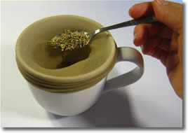Step 2: Stretch the stocking over a large cup or mug, and spoon in about 2 teaspoons full of grass seeds.
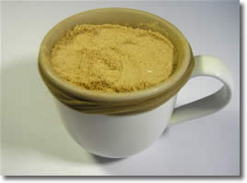Step 3: Pack in some sawdust or potting soil. Aim for the head to be roughly tennis ball sized.
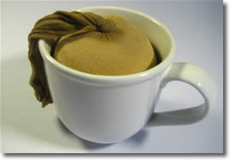Step 4: Tie a knot to close the end. No need to cut off the dangly bit.
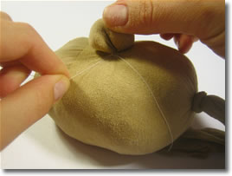Step 5: You can make a bulbous nose or ears by grabbing a bit of stocking and twisting. Fasten base of the nose with some thread or a small rubber band.
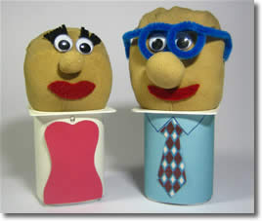Step 6: Decorate! Use fabric scraps or permanent marker to decorate the face, and coloured paper to make the yoghurt container into a dress or a suit or whatever you like - get creative! Just make sure that any glues or markers you use for the head are water-proof.

Growing your Grass Heads
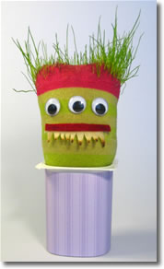
Grass grows a bit unreliably through a sock
When you're ready to grow your head, give it a good dunking in a bowl of water to moisten the sawdust/soil. Half-fill the yoghurt container with water, and put the head on top, with the excess stocking dangling down into the water.
Put your creation on a windowsill or somewhere with plenty of sunlight. Check every day to make sure the head is moist - you might need to dribble a few drops of water onto the head now and then.
"Hair" takes about 1 week to sprout. A full head of hair takes 3-4 weeks to grow, and and "greying and balding" will occur after about 6 weeks. Experiment with different hairstyles :-) You can make mohawks, pony-tails, crew-cuts... have fun with it!

