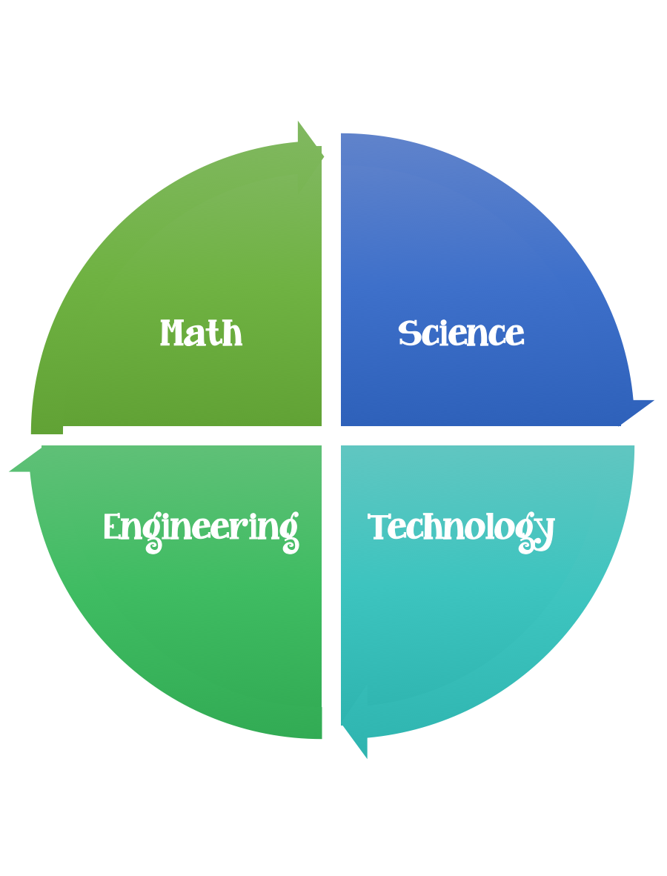
Findley Oaks STEM Connect
1st Grade Design Brief

Month  February | Challenge  Traveling Pets | Unit  Animals
Standard:
Students should follow the engineering design process.
Background/Problem: Read a story about pets. You learned information about many animals that make good pets. Sometimes people need to take their pets places -on trips, to the vet, to an animal show. You brought a stuffed “pet” to school, and now you need to take your “pet” to your STEM class.
Design Challenge: Working with a partner, design and create a container that you can use to safely and successfully to take your “pet” and your partner’s “pet” to visit your STEM class. Your “pets” must travel to and from your STEM class safely, without falling out or getting hurt and must be able to rest safely and comfortably while you are in your STEM class. You and your partner must be able to independently carry your container with you “pets” inside.

Criteria:
Your container must:
- have at least one moving part.
- have an opening to take your pets inside and out.
- have another opening so that your pets can look out and see where they are going and what you are doing in your STEM class.
- have a handle so that you and your partner can carry it.
- hold your “pets” inside, safely and comfortably.
- be decorated.
- You must work with a partner.
- You have one hour to create and decorate your container. (Your teacher has the option of allowing more time.)
- You really will use your container to take your “pets” to the next STEM class.

Constraints: You can only use the materials provided. Everyone in your group needs to participate.
Materials: (per group of 2)
Cardboard
Poster board
Boxes
Glue and/or glue sticks
Pom-poms
Toilet paper and toilet paper rolls
Rubber bands
Brads
Tape
Craft sticks
Yarn
Beads
Ribbon
Pipe cleaners
Anything in the scrap box
Construction paper
Anything else your teacher puts out for you to use

Tools:
Markers and / or crayons
Scissors
Crazy scissors
Hole punch
Staplers
Rulers

Paper (For design planning)
Pencils

