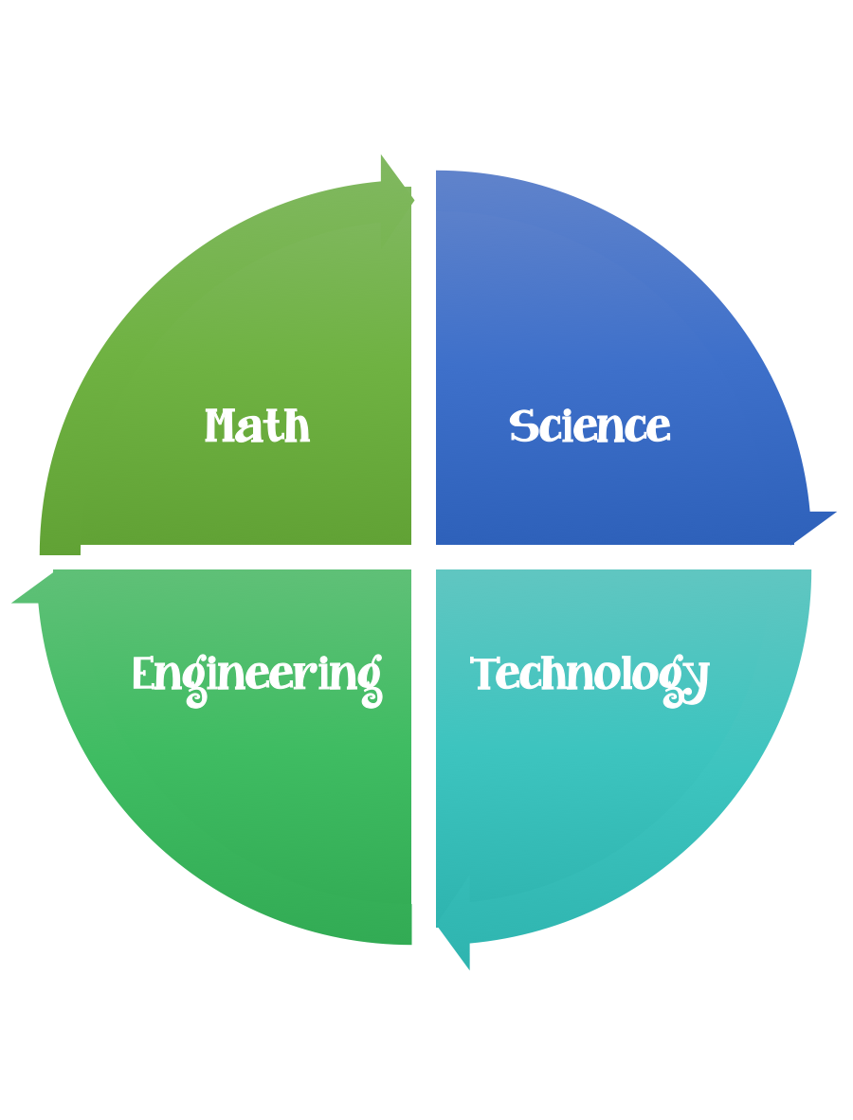
Findley Oaks STEM Connect
2nd Grade Design Brief

Month  January | Challenge  Marble Challenge  Don’t Lose Your Peaches | Unit  Sources of Energy
Standard: I can define a simple design task/problem reflecting a constraint on materials, time, or cost.
Students should follow the Engineering Design Process.
Background/Problem: A shipment of Georgia Peaches (marbles) from the producers need to be delivered efficiently to the consumers. The engineers working on this project need your help designing a conveyer belt.
Design Challenge: Your challenge is to create/design a free standing structure that has a track on which the peaches can travel. You will be awarded points for the height of the structure at the point where the marble begins its ascent down the track. Points will also be awarded for each right angle turn in the track. You will be allowed 5 marble runs. You will start each marble at the top of the track and let it go. You will receive points for each marble that successfully travels all the way down the track. Additional points will be awarded for marbles caught in a container at the end of the track. You will receive points for meeting the following criteria.

1 point – for each centimeter of height.
5 points – for each 90 degree angle turn in the track.
1 point – for each marble that successfully travels the entire length of the track, but dos not land or stay in a container at the end of the track.
5 points – for each marble that travels the track and stays in a container at the end of the track.

Criteria:
Your conveyer belt must:
- have a start and a stop point.
- have at least 4 angles in it.
- the peaches must drop into a cup at the end.
- travel without stopping.
- be at least 30 centimeters tall.

Constraints:
- You will be allowed 5 marble rolls.
- Each marble must start at the start line.
- 5 Points will be awarded for each successful marble run.
- All team members must participate, if the structure breaks, make repairs or start again.
- The structure must remain standing when completed.
- You have 30 minutes to complete your build.

Materials: (per team or group) 2,3, or 4 (teacher discretion)
6 straws
10 Q-tips
6 index cards
½ stick modeling clay
12” inches of masking tape
1 small paper cup
1 marble
1 copy paper box lid

Tools:
Rulers
Paper/pencil for design planning
scissors

