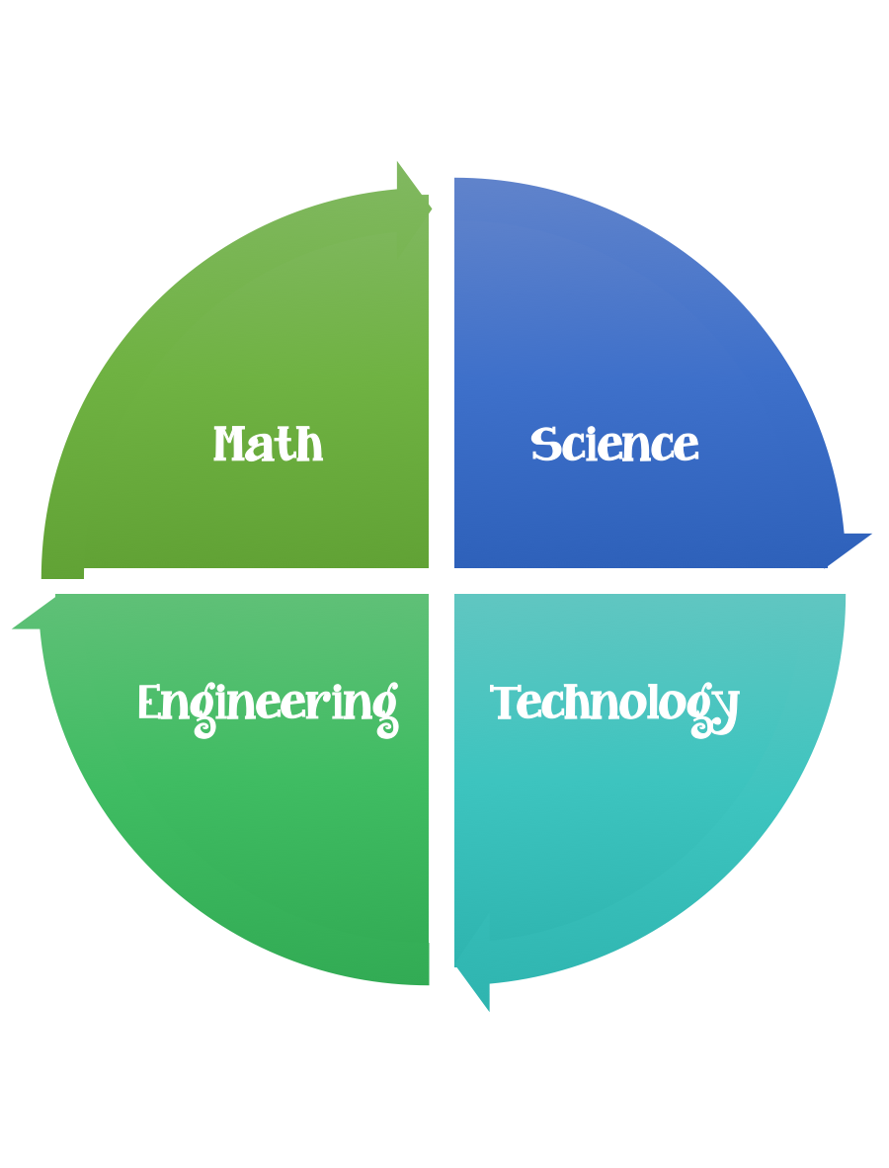
Findley Oaks STEM Connect
2nd Grade Design Brief

Month  March | Challenge  Tissue Paper  Life Cycle Collage | Unit  Life Cycles
Standard:
Students should follow the Engineering Design Process.
Background/Problem: We have been learning about life cycles. Your teacher needs your help teaching others about four stage life cycles by creating a collage. Can you help.

Design Challenge: Your challenge is to pick an insect or animal that has four stages and design a collage out of tissue paper that is torn and made to represent each stage.
Criteria: Your collage needs to:
- contain the life cycle stages
- be made out of tissue paper
- be glued onto a transparency

Constraints:
All members of your team must participate
You can use some of are all of the materials.

Materials: (per team or group) 2,3, or 4 (teacher discretion)
Transparency paper – left over overhead paper
Tissue paper (assorted colors)

Tools:
Rulers
Scissors
Glue and/or Glue Sticks
Paper/pencil for design planning

