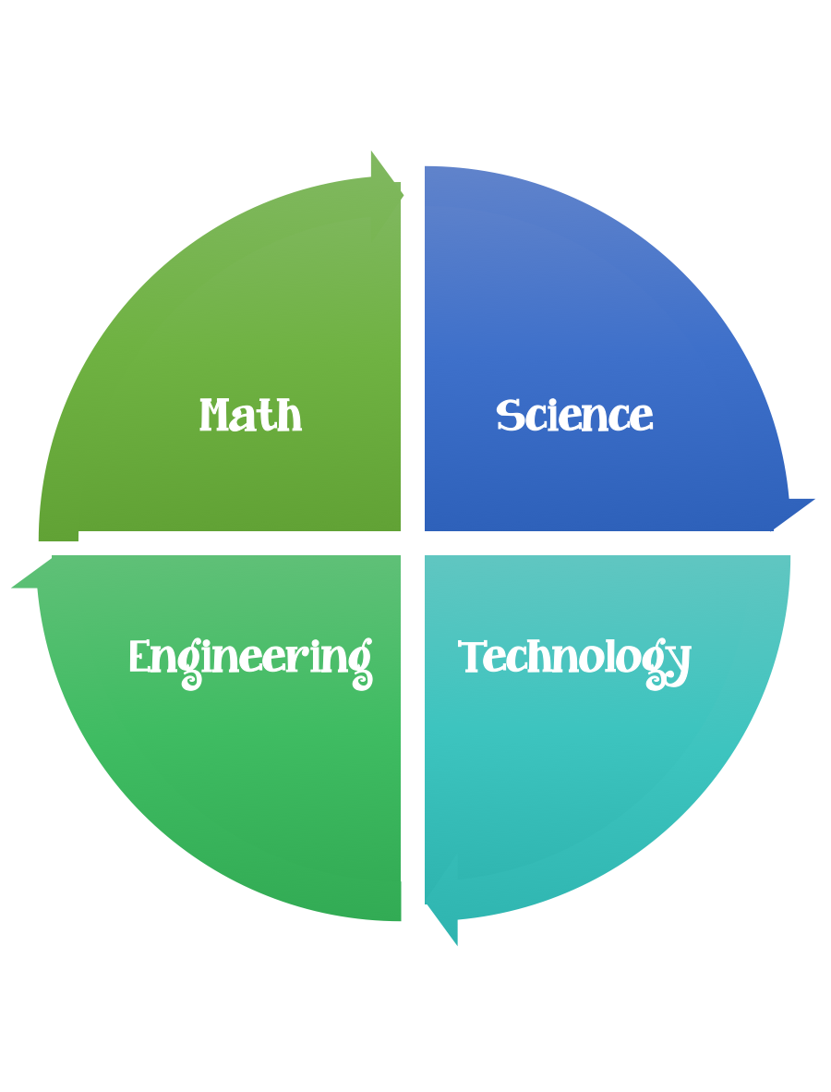
Findley Oaks STEM Connect
3rd Grade Design Brief

Month  August | Challenge  Bird’s Nest | Unit  Georgia Habitats
Standard:
Students should follow the Engineering Design Process.
Background/Problem: Birds build their habitats out of natural resources that they find outdoors. They use mud, sticks, straw, twigs, leaves, feathers, and grass.
Design Challenge: Your design challenge is to build a bird’s nest out of the material provided and see how many eggs it can hold.
Criteria: Your nest must:
- be shaped like a bowl.
- be made out of mud, twigs, sticks, grass, feathers, and leaves.
- be as strong as possible.
- be between 5 and 10 centimeters tall.
- Be at least 5 centimeters wide.

Constraints:

You must work with a partner (or in a group of 3) teacher discretion.
You can use some of are all of the materials.
You will make one nest together.
Test out your nest by pacing it in a low branch of a tree, or you can tape 3 rulers or yardsticks together into a triangle to simulate a tree branch. Place hard-boiled eggs in it. How many can it hold?

Materials: (per team or group) 2,3 (teacher discretion)
Mud
Straw
Grass
Twigs
String
Sticks
Leaves
Feathers
6 Hard boiled eggs for testing –how many can your nest hold?
Sticks/rulers/yardsticks
(a foot long) 3 for testing

Tools:
Markers/crayons
Stapler
Hole punch
Rulers
Scissors
Crazy scissors
Glue and/or Glue Sticks

Paper/pencil for design planning

Options: weigh your nests, measure you nests, weigh the eggs

