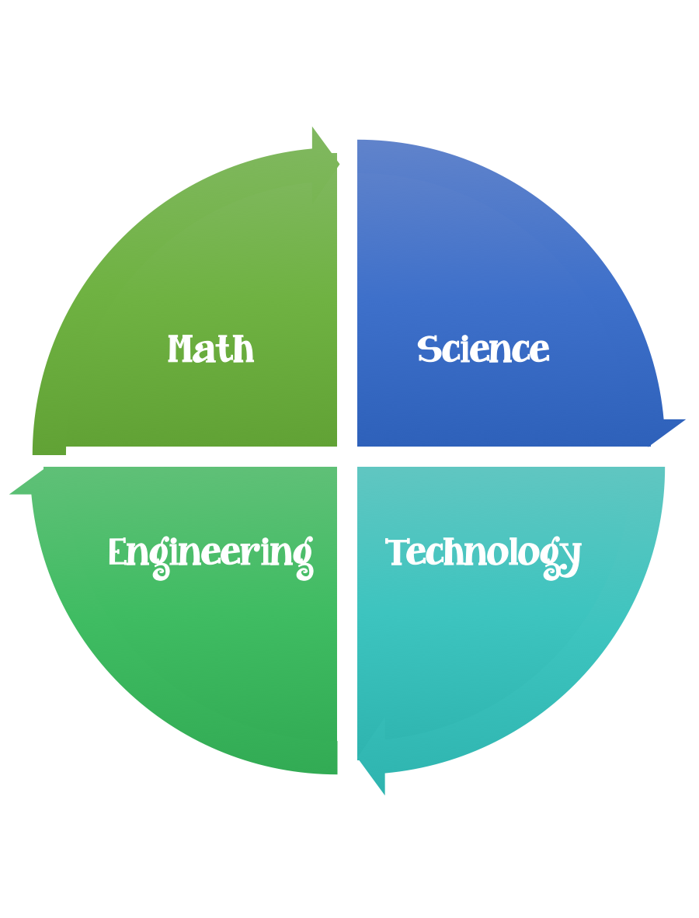
Findley Oaks STEM Connect
3rd Grade Design Brief

Month  February | Challenge  Engineering for the Three Little Pigs | Unit  Rocks and Minerals
Standard:
Students should follow the Engineering Design Process.
Background/Problem: The purpose of this activity is to demonstrate the importance of rocks, soils and minerals in engineering and how using the right material for the right job is important. The students build three different sand castles and test them for strength and resistance to weathering. Then, they discuss how the buildings are different and what engineers need to think about when using rocks, soils and minerals for construction.

Engineering Connection
When designing structures, engineers must understand the material properties of rocks, soils and minerals and how these properties change when mixed together. Engineers must also make sure that the rocks, soils, and minerals are strong and safe enough for the job. Other material constraints might include ease of manipulation and material expense.

Introduction/Motivation
What kinds of materials are used to make buildings? Do you know? Some buildings are made of wood, stone, steel, concrete, brick or adobe (List these on the board.) Which of these come from a rock, soil or mineral? Almost all of them are directly made from rocks, soils and minerals. From the list we made, only wood is not actually a rock, soil or mineral. However, since trees need soil to grow, wood is still closely related.

When building any type of structure, engineers need to make sure they pick the right material for the job. Let's think about some examples. (Start a new list on the board of the material properties engineers consider from the examples below.) Why do you think engineers do not build airplanes out of marble? Well, marble is too heavy, and the plane might not be able to lift up into the air! So engineers use aluminum, which is still strong, but much lighter. Engineers do not always have to think about the weight of a material when building something. Why don't engineers build big skyscrapers out of wood? Wood is not strong enough to hold up such a tall structure. We can use wood to build houses, because they are shorter. So, engineers have to think about the strength of the material they are using. However, wood is still cheap and easy to work with. Why don't engineers build bridges out of diamonds? Diamonds are very strong, but they are incredibly expensive, and building a bridge out of diamonds would be very difficult. Engineers have to think about how much a material costs when they are using it as well as how easy it is to work with the material. Why don't engineers build houses out of concrete? Sometimes they do, but usually houses are built out of wood or bricks because people like the way it looks better than concrete. Engineers have to think about the way things look when building something, as appeal is a great motivator for finished products.
So, many of the materials that engineers use when they are constructing come from rocks, soils and minerals. Engineers need to know about the properties of the different materials and how to use them in order to create something that is heavy or light enough, strong, cost effective and aesthetic (looks good), as well as functional, safe and reliable.
Design Challenge: Today, we are going to create buildings out of different materials. You are going to be the engineers who figure out which materials are best for the buildings we are making, taking into consideration all the properties of materials that we have discussed.

Learning Objectives
After this activity, students should be able to:
- Explain that combining different materials is necessary when using rocks, soils and minerals for construction.
- Explain how engineers need to consider material properties of rocks, soils and minerals when creating something new.

Criteria: Your creation must:
- be strong, sturdy, and stable.
- be made out of the materials provided.

Constraints:
You must work with a partner (or in a group of 3) teacher discretion.
Make sure you have a design plan before you start.

Materials: (per team or group) 2,3 (teacher discretion)
Each group needs:
- 6 bathroom-sized paper cups ("Dixie" cups)
- 1 small bowl for mixing ingredients
- 4 cups of sand
- 5 tsp. white glue
- 1 cup water
- 2 plastic spoons (about teaspoon-sized)
To share with the entire class:
- 1 permanent marker, any color
- 1 watering can
- a few bricks
- 1 can of non-stick cooking spray
- safety glasses

Tools:
Scissors
Crazy scissors
Staplers
Hole punch
Rulers

Part I: Building
About four days before the testing part of the activity, have the students construct four of the buildings as follows.
- Carefully measure out glue and mix 4 tsp. of glue with 4 tsp. of water in the mixing bowl Add two full Dixie cups full of sand to the glue/water solution and stir until you have a completely damp sand mixture.
- Spray the inside of two bathroom cups with the non-stick spray.
- Place this mixture into the two bathroom cups so that they are nearly full.
- With a permanent marker, write "B" on the sides of the bathroom cups.
- Set the cups aside so they can dry for at least four days.
- Mix 1 tsp. of white glue with 6 tsp of water in the bowl.
- Add two full bathroom cups full of sand to the glue/water solution and stir until you have a completely damp sand mixture.
- Spray the inside of two bathroom cups with the non-stick spray.
- Place this mixture into the two bathroom cups so that they are nearly full.
- With a permanent marker, write "C" on the sides of these bathroom cups.

- Set the cups aside so they can dry for at least four days.
Part 2: Testing
- Before Part 2 of the activity, make sure that the B and C labeled buildings (filled bathroom cups) are completely dry.
- Have each group mix 2 bathroom cups full of sand with 6 tsp. of water in the bowl. Have them fill the two remaining bathroom cups with this damp sand (no glue). Mark an "A" on these cups.
- Have each group take their two A, two B and two C cups outside with a watering can and a brick.
- Have each team carefully turn over one of their A cups and place it on the ground. It is best if this is done on a dirt patch, but concrete and asphalt work as well. Then have them slowly pull the cups off, leaving the damp sand.
- Then have one student from each group pour water on his/her building using the watering can. Ask the students what they observed. Did their buildings remain standing? What does the water from the watering can represent? (Answer: Rain or erosion.)
- Have each group set up their second A building on the ground in the same way they did with the first one. Have them try and set the brick on top of the building. Ask the students what they observed. Is the building able to hold up the brick? What do they think the brick represents? (Answer: The brick represents the weight of people, furniture and other objects [loads] that the structure must hold up. Engineers often test buildings by adding more weight to them than is realistic, since it is better to be safe than sorry. This is called a safety margin.
- Next, have students get one of their B buildings and place it on the ground. Have them tear away the cup from the sand, water and glue mixture very carefully.
- Then have one student from each group pour water on their B building using the watering can. Ask the students what they observed. Did the building remain standing? Did it hold up better or worse than the A building? Why did this building do better? (Answer: The glue helped hold the sand together.
- Have each group set up their second B building on the ground in the same way they did with the first one. Have them try and set the brick on top of the building. Ask the students what they observed. Does the building hold up the brick?
- For buildings that are still standing, have groups hold their bricks 6 inches above their buildings. On the count of 3, have them drop a brick on each building. Have them describe about their observations.
- Repeat steps 7-10 with the C buildings. Discuss how well the C buildings did compared to the A and the B buildings.

Safety Issues
- When dropping the bricks, have the other students stand back several feet to avoid getting sand in their eyes. Have the dropper wear safety glasses.

Troubleshooting Tips
Students may need help peeling the paper cups off their sand buildings

Assessment
Pre-Activity Assessment
Poll: Before the activity, ask all students the same question. Have students raise their hand to answer the question. Write answers on the board, and summarize (in percentages or actual number of students) who answered the same or similarly. Ask students:
- If you had to build a house out of soil, would you rather have one built out of rough sand, medium-grain silt or fine-grain clay? (Answer: While sand castles are fun to build, they are not very strong; once they dry out, they usually crumble easily. Silt-type soil is good for growing plants, but it does not hold together well enough for the creation of a building. Clay is the best option. In fact, some buildings are really made out of clay when you realize that materials such as concrete, brick and adobe have a high clay content.)
Activity Embedded Assessment
Prediction: Have students predict which buildings (A, B or C) will hold up best under water (weather) or the brick (weight) and record predictions on a sheet of paper or the board.
Group Question: During the activity, ask the groups:
- Which buildings survived the weather and weight the best? Why? (Probable answer: It is most likely that the C building survived the best. This is because sand and water do not hold together well, and the glue holds the sand together better. It is important that engineers understand the properties of rocks, soils and minerals in order to design successful structures. In this scenario, our buildings were made of sand and glue — sand being a soil and glue being composed of
- different minerals. In the real world, engineers design many buildings using concrete, which is a mixture of minerals, rocks and soils.)
Post-Activity Assessment
Engineering Cost Analysis: Ask students to think about the situation if they had to live in a sand house: would they want live in a house like building A, B or C? Engineers also often must consider materials cost and other factors when building a house. Which of these buildings is the most expensive to build? Have the students think about the following cost problem:
- What if it turned out that the sand costs 5 cents for one-bathroom cup full, glue costs 10 cents for one teaspoon, while water costs 1 cent for one teaspoon? (Answer: Each building A was built with 3 teaspoons of water and 1 cup sand – therefore costing about 7 cents a piece. Each building B was made with 2 teaspoons of glue, 2 teaspoons of water and 1 cup of sand – therefore costing about 27 cents a piece. Each building C was made with ½ teaspoon of glue, 3 teaspoons of water and 1 cup of sand – costing 13 cents each. In this case, it is probably best to have a C building since it is much cheaper than a B building, and it works nearly as well.)
- Discuss with the students how engineers must constantly weigh the pros and cons a design to come up with the best design. For example, we could build buildings out of titanium since it is incredibly strong; however, we do not actually build them out of titanium since it is so expensive and buildings do not need to be that strong in order for us to safely live in them.

Activity Extensions
Have students build other buildings using different materials such as cement, clay, plaster and assorted soils. Test these buildings in the same way to determine which are successful and which are not. Then, discuss how these materials come from rocks, soils and minerals to reinforce their importance to engineering.

Assessment

1. Which term is defined as the breakdown of rock into smaller pieces?
- a. erosion
- b. weathering
- c. sloping
- d. lifting
2. All of the following are typical agents of erosion except:
- a. sound.
- b. moving water.
- c. wind.
- d. gravity.
3. A large boulder falls from a cliff and breaks into many smaller pieces. The smaller pieces of the rock are then moved to a new location by moving water. This is an example of:
- a. erosion, only.
- b. weathering, only.
- c. both erosion and weathering.
- d. neither erosion nor weathering.
4. Liquid water settles into the crack of a large rock. The water freezes and the large rock splits into two smaller rocks. This is an example of:
- a. erosion, only.
- b. weathering, only.
- c. both erosion and weathering.
- d. neither erosion nor weathering.
5. Material A has a small volume and small mass, while material B has a small volume, but a much larger mass. Which material, A or B, would be expected to undergo greater movement due to erosion?
- a. material A
- b. material B
- c. materials A and B would undergo similar rates of movement due to erosion

6. As the steepness of a slope increases, the erosion of materials on the slope is expected to:
- a. decrease.
- b. increase.
- c. remain constant.
7. The application of ground cover on a slope is more likely to reduce the rate of erosion on the slope than a reinforced retaining wall.
- a. true
- b. false
8. Soil lifts are most similar to:
- a. sand bags.
- b. elevators.
- c. small trees.
- d. small bushes.

Engineering Connection
Civil and geotechnical engineers carefully investigate the soil in the surrounding area where structures are going to be built so they can best plan for the future safety of the structures. Civil engineering projects such as skyscrapers, bridges and highways require solid foundations, and preferably placement in areas that are not susceptible to erosion. Engineers must also be knowledgeable of the types of construction materials that can resist water erosion. Engineering solutions to erosion problems may include the extension of foundation systems, installation of vegetation, and modifying the water flow or direction. The erosion table demonstration in this activity shows students how water can move soil and how erosion can affect buildings.

