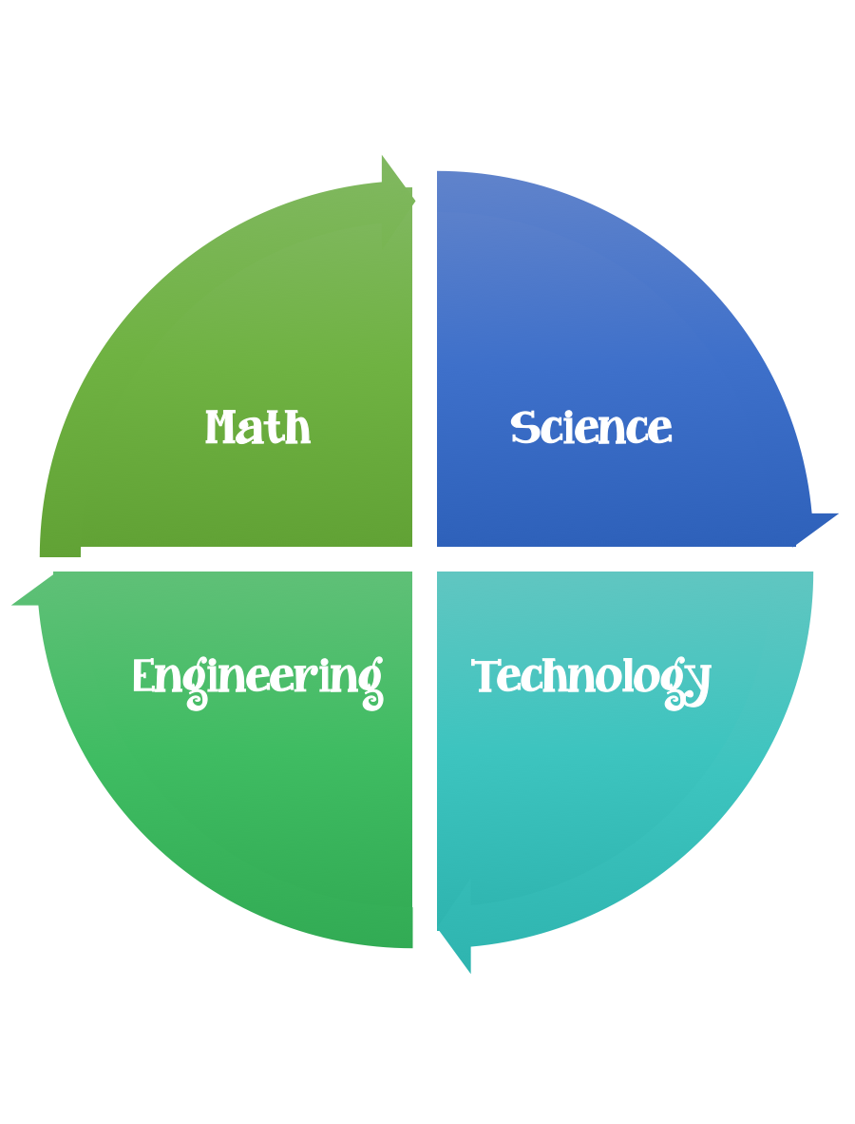
Findley Oaks STEM Connect
3rd Grade Design Brief

Month  October | Challenge  Water Filter | Unit  Pollution and Conservation
Standard:
Students should follow the Engineering Design Process.
Background/Problem: Engineers are always trying to find ways to improve things/make things better. Being able to provide clean water to people around the world is challenging.
Design Challenge: Hydro –neers needed to invent a filter to clean dirty water.
Criteria: Your water filter must:
- be able to filter dirty water.
- be made out of the materials provided or you may use only two to make it more challenging.
- Make a prediction and a plan before you start.

Constraints:
You must work with a partner (or in a group of 3) teacher discretion.
You can use some or all of the materials.

Materials: (per team or group) 2,3 (teacher discretion)
2 – liter soda bottle cut in half (by an adult)
napkins or paper towels
gravel, sand, and cotton balls for you filter
rubber bands
coffee filters
dirty water – you can make it by adding cooking oil, food coloring, pieces of paper, and tiny pieces of Styrofoam to water

Tools:
Scissors
Water Tables (In Science Lab)

Paper/pencil for design planning

Options:

Possible directions: Teacher resource only.
- Put the top half of the soda bottle upside-down (like a funnel) inside the bottom half. The top half will be where you build your filter; the bottom half will hold the filtered water.
- Layer the filter materials inside the top half of the bottle. Think about what each material might remove from the dirty water and in what order you should layer the materials. For an added challenge, use only two of materials to build your filter.
- Pour the dirty water though the filter. What does the filtered water look like?
- Take the filter apart and look at the different layers. Can you tell what each material removed from the water?
- Wipe the bottle clean and try again. Try putting materials in different layers or using different amounts of materials.

