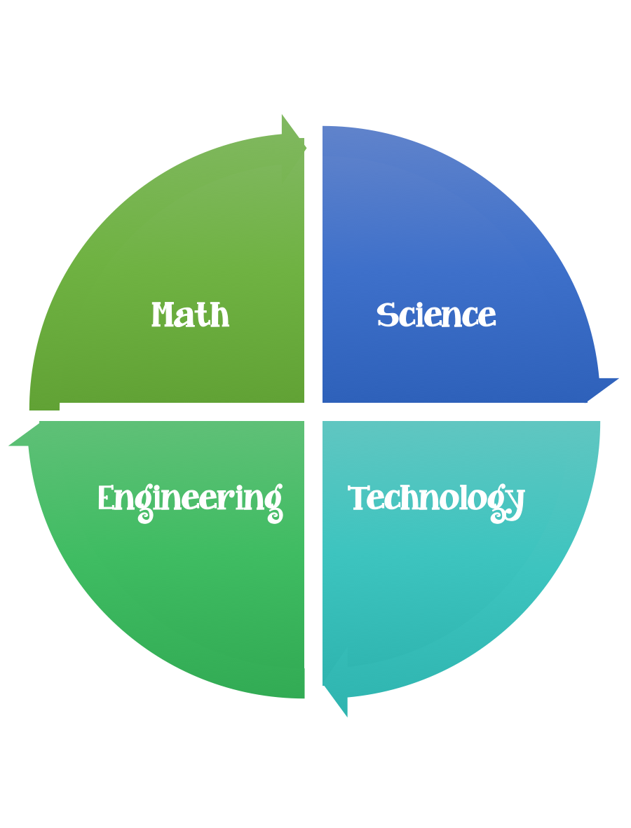
Fulton County STEM Connect
Kindergarten Design Brief

Month  August | Challenge  Marshmallow and Toothpick Shape Build | Unit  Physical Properties
Standards: Math – Geometry
•CCSS.Math.Content.K.G.A.2 Correctly name shapes regardless of their orientations or overall size.
•CCSS.Math.Content.K.G.B.5 Model shapes in the world by building shapes from components (e.g., sticks and clay balls) and drawing shapes.
Students should follow the engineering design process.
Background/Problem: Your teacher _______________ needs your help. She cannot remember the names of all the shapes that we have been learning about. Can you build shapes out of toothpicks/spaghetti and mini marshmallows then review their names with her?
Design Challenge: Students will build 2D shapes out of toothpicks/spaghetti and marshmallows and describe their sides and vertices.
Criteria: All eight shapes need to be built. Pick your favorite shape and then complete the attached worksheet.

Constraints: You may not eat any of the marshmallows. You will have 45 minutes to complete this assignment.

Materials: toothpicks or spaghetti, marshmallows
Tools: worksheet and pictures

