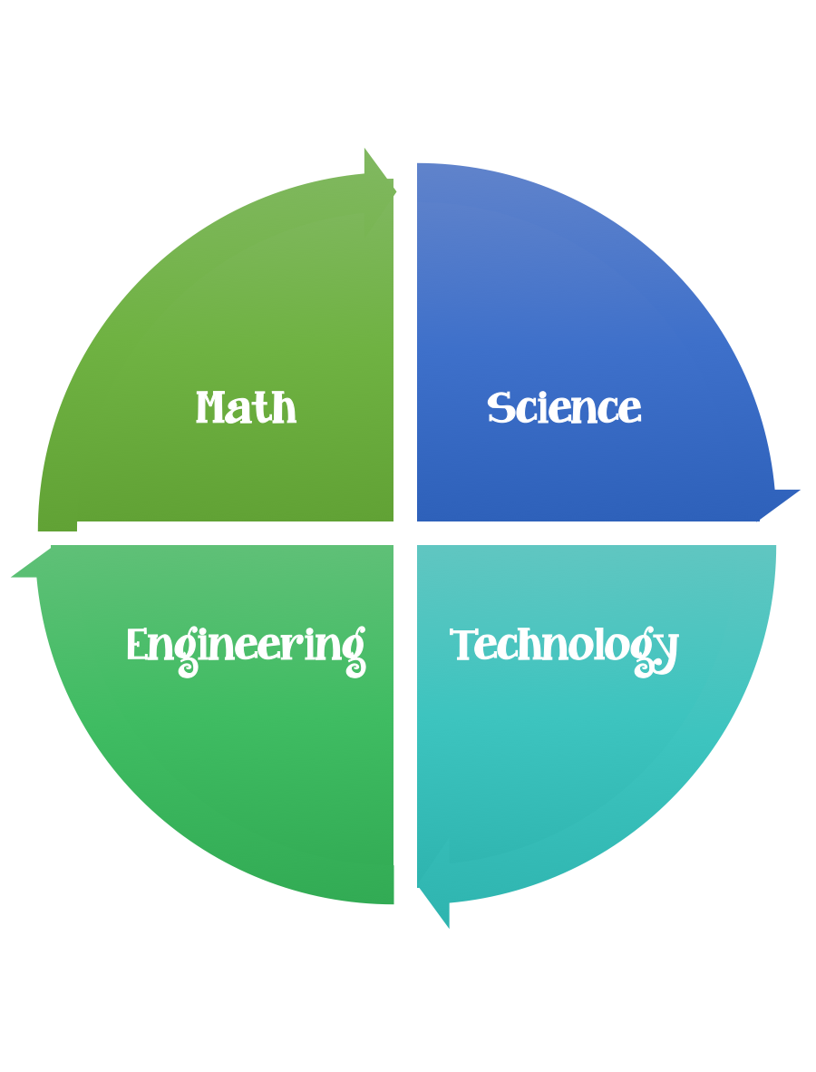
Fulton County STEM Connect
Kindergarten Design Brief

Month  February | Challenge  Umbrella for Smokey Build | Unit  Animals
Standard:
Students should follow the engineering design process.
Background/Problem: Smokey the Bear is tired of getting wet all of the time and needs an umbrella. He has been very busy talking about fire safety to everyone and hasn’t had a chance to go shopping. Can you make an umbrella for Smokey?
Design Challenge: Create/design an umbrella for Smokie the Bear. Think about what a great service he does teaching us about fire safety. If you could ask him a question what would you ask?
Criteria: Your umbrella needs to be able to have water sprayed on it for 60 seconds and still be assembled for 10 minutes after. Everyone in your group needs to participate. Your umbrella needs to be between 10 and 20 unifix cubes tall.

Constraints: You can only use the materials provided to make your umbrella.

Options: Brainstorm what worked and what didn’t. What would you do better next time? How did your group work together?

Materials: (per teams of 2, 3 or 4) teacher choice
Grocery bag
Sheet of copy or construction paper
Sheet of overhead plastic or other type of plastic (left over laminate)
10 straws
10 craft sticks

Tools:
Small teddy bear or use cutout below
Glue
Scissors
Paint
Markers
Rulers
Pencil
Paper
Squirt bottle to test the umbrella

