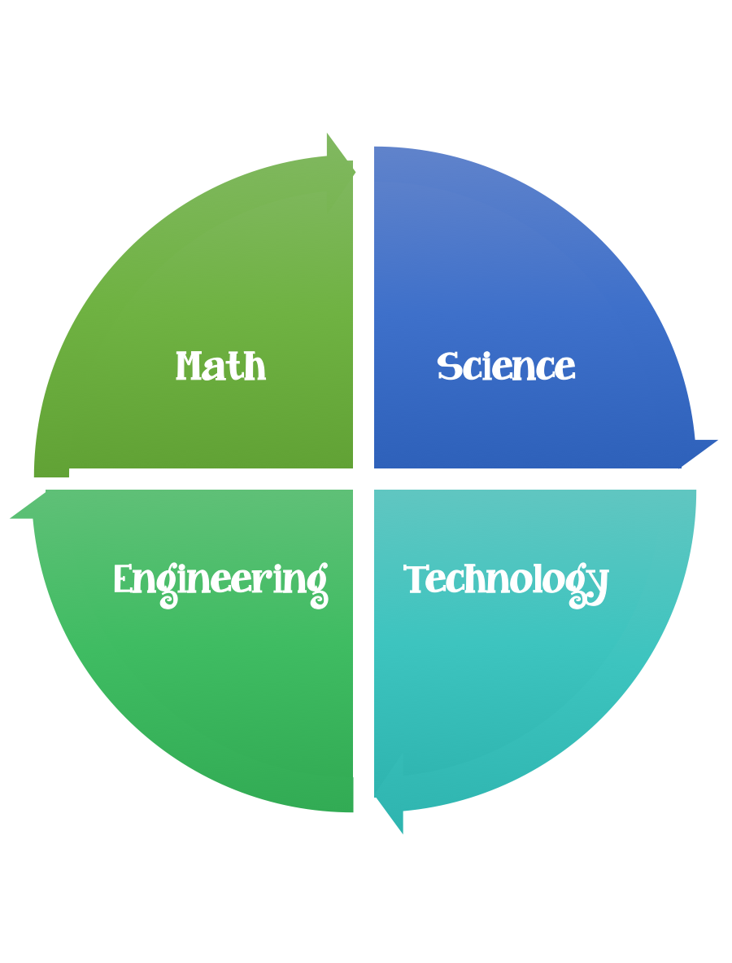
Fulton County STEM Connect
Kindergarten Design Brief

Month  January | Challenge  Pet Rock | Unit  Rocks, Water, Soil, and Air.
Standard:
Students should follow the engineering design process.
Background/Problem: There are so many different types of rocks, just like kids. Yet. they are all very special in their own way. Your class has decided to adopt a few rocks for classroom pets. Your teacher needs a way to be able to distinguish them from each other. Can you take care of a pet rock and help your teacher distinguish them from all of the others?
Design Challenge: Students will bring into class a rock they found of their choice. They will need to give it a bath and dress it. Wiggly eyes will help it see. Possibly a fresh coat of paint will make it feel good about itself. They should brainstorm a design plan before they start/glue. Option: create a habitat for it. Your pet will also need a name, think of something special/different.
Criteria: Your pet rock needs to have a bath, a fresh coat of paint, wiggly eyes, and hair.

Constraints: You can only use the materials provided to take care of your pet. The name of your pet should not be the same as anyone else’s in the class. You will have about 30 minutes to bath and dress you pet. The My Pet Rock sheet needs to be completed to help your teacher differentiate your pet from the rest of the class. (Parent volunteers might need to help with this)

Options: Make a class graph of the elements that the students explored.

Materials: (per student)
Rock
Wiggle eyes (2)
Silly colored hair
Tools:
Glue
Scissors
Paint
Markers
Rulers
Pencil
Paper

Optional: (to make habitat)
Small boxes/containers
Shredded tissue paper

