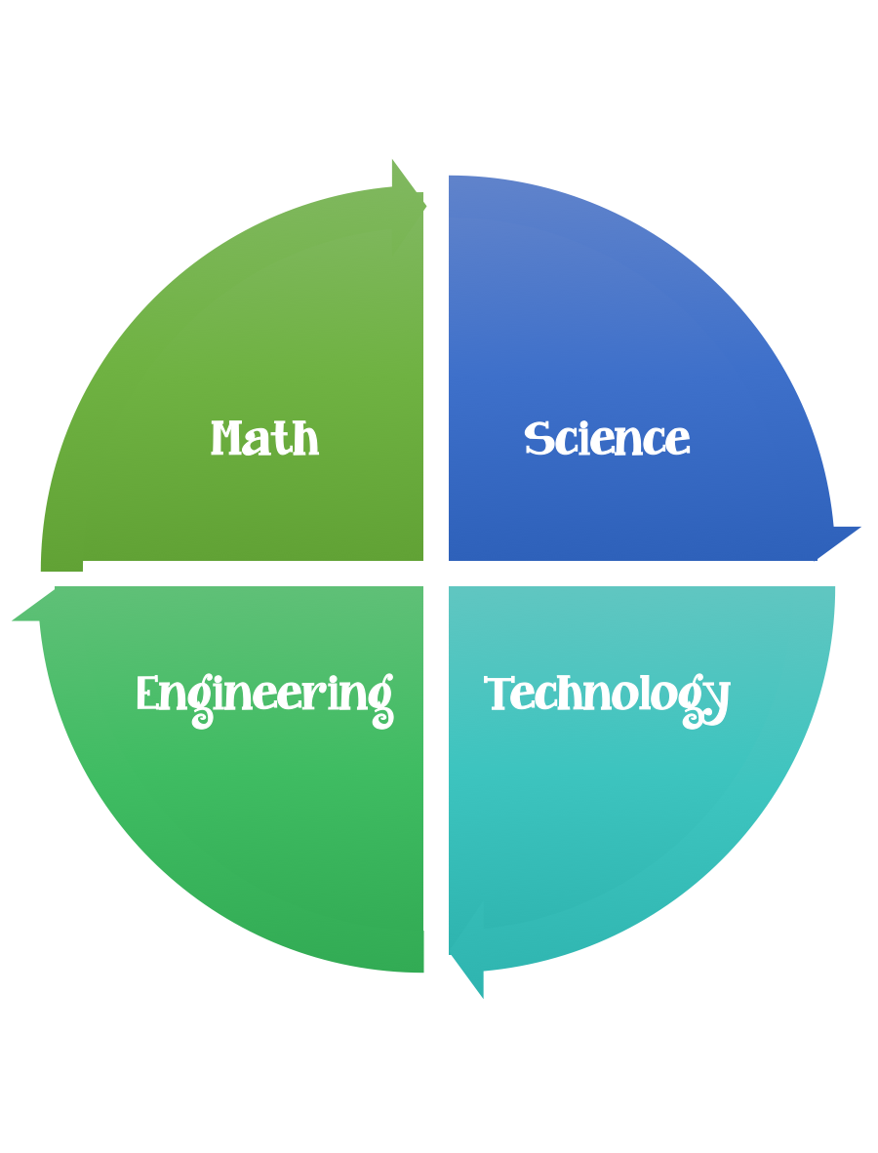
Fulton County STEM Connect
Kindergarten Design Brief

Month  November | Challenge  Day and Night Sky Diorama | Unit  Time Patterns in Day and Night Sky
Standard:
Students should follow the engineering design process.
Background/Problem: Read a book about the day and night sky. (Chicken Little) http://www.edsanders.com/chickenlittle/
Design Challenge: Students will create a giant diorama of their own falling sky by making items that belong in the day or night sky. The night time items are on top of the table and the day time items are taped using string to the bottom of the table.
Criteria: Each student should make at least one item for the day sky and one for the night sky. Items should be attached in a way that they are standing upright or suspended.
Constraints: Items need to be larger than 6 unifix cubes and shorter than 10 unifix cubes. Items need to be made out of at least two different types of materials.

Materials:
Cotton balls
Construction paper
Pipe cleaners
Popsicle sticks
Items from recycle bin
String
Clear Tape

Tools:
Crayons
Markers
Rulers
Hole Punchers
Glue
Scissors

