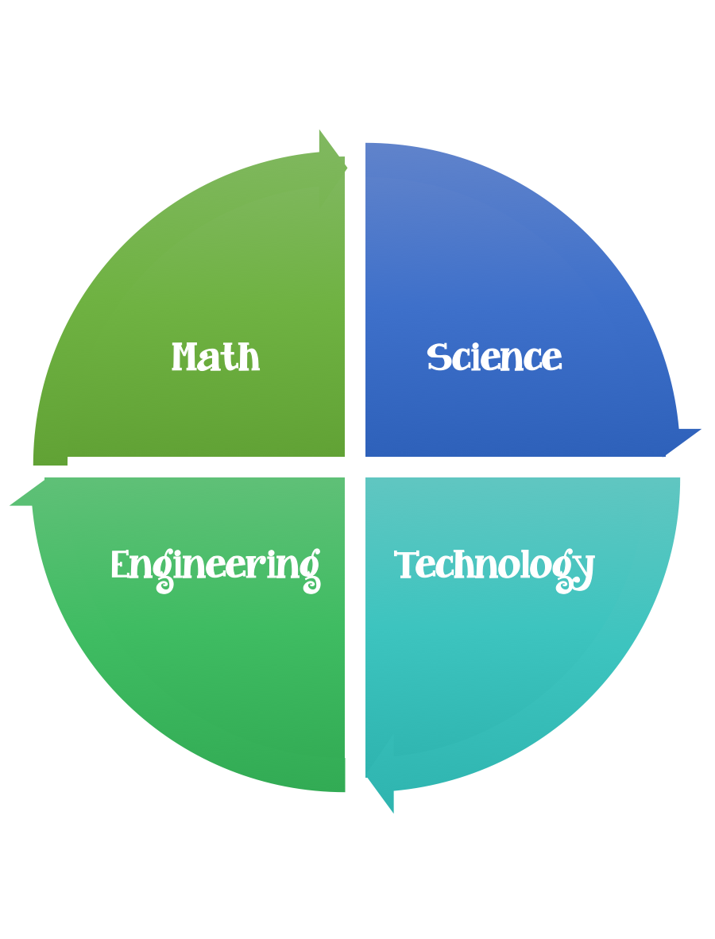
Fulton County STEM Connect
Kindergarten Design Brief

Month  September | Challenge  Toilet Paper Tube Sail Cars | Unit  Motion
Standard:
Students should follow the engineering design process.
Background/Problem: BMW needs your help designing a wind powered car. The citizens in Johns Creek would like to cut down on their monthly gasoline expenses.
Design Challenge: Students will build a car that is wind powered and that can travel 20 centimeters.
Criteria: The car must have four round wheels and two axles. The shape of the sail needs to be able to catch the wind to make it move.
Constraints: The car must be made out of the materials provided. You will have 45 minutes to complete this assignment.
Materials:
-Toilet paper tubes or paper towel rolls cut in two
-Empty tissue boxes (fun designs to be used as wheels and sails
-Skewer sticks with tips cut off, regular popsicle sticks (plain or colored)
-Masking tape
Tools: Scissors

- Cut the sail and the wheels out of the tissue boxes.
- Poke the skewer through the toilet paper roll and attach the wheels.
- Poke the popsicle stick into the top of the toilet paper roll.
- Attach the sail with the masking tape.
- Options: Paint, draw a person to drive the car and attach.
Possibly ask for parents to precut the wheels or use vanilla wafers.

Reference: http://nerdybaby.blogspot.com/2012/01/toilet-paper-tube-sail-cars.html

