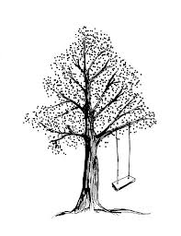Publicity Release Form
Findley Oaks Elementary
□(Please initial)
Yes, I grant permission for Falcon Invitational Math Tournament to use or publicly display my child (name______________________)’s photograph, video, or audio clip on web sites, newspapers, and/or television news shows without further notice. I also agree that the photographs of my child/I can be used on newsletters, calendars, brochures, magazines, internet, videotaping and the like.
□(Please initial)
No. I don’t want my child (name______________________)’s to be interviewed, photographed and videotaped for publicity purposes.

Not providing permission for your child will also retain team photos from being released.

