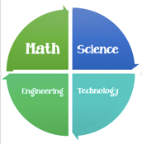 Parent STEM Opportunities Volunteer Sign-up
Thank you, thank you, and thank you!
Parent(s) Name: __________________________________
Email: ___________________________________________
Student’s Name: __________________________________
Teachers Name: __________________________________
I am currently or have previously worked in (circle)
A Science Math Engineering Math field.
Please list your job title and explain a little about what you do.
__________________________________________________________________________________________________________________________________________________________________________________________
I would be happy to: (Check all that apply)
Talk to students in my child’s classroom about what I do.
Talk to students in any classroom about what I do.
Help in my student’s classroom.
Help in any classroom.

