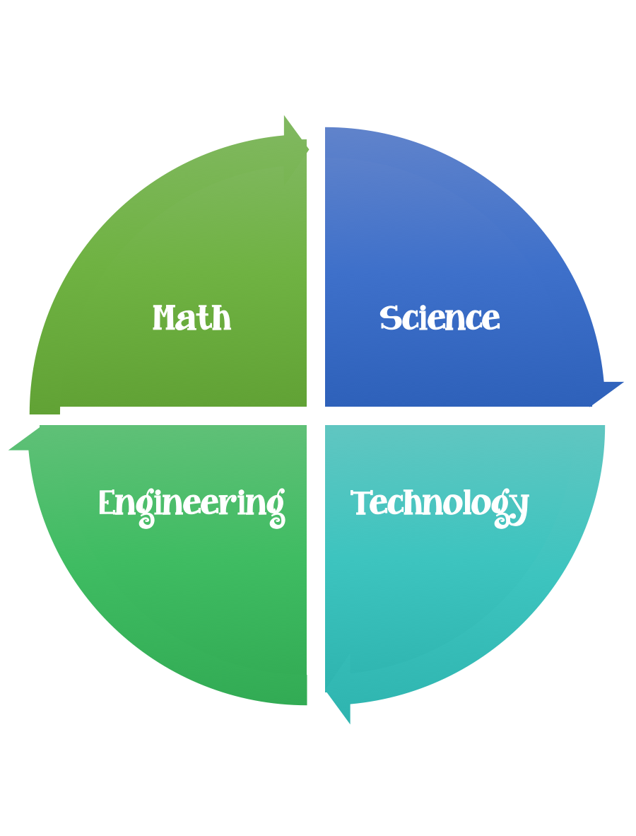
Findley Oaks STEM Connect
1st Grade Design Brief

Month  January | Challenge  Build a Snowman | Unit  Weather  Changes in Water
Standard:
Students should follow the engineering design process.
Background/Problem: The city hall decorators are running behind schedule. The Mayor of John’s Creek (Mike Bodker) needs help decorating City Hall. He would like for you to build really tall snowmen to put in the foyer. Can you help him?
Design Challenge: Working in a small group and using the materials and tools provided, design and create the tallest snowman.
Criteria:
Your snowman must:
- Be free standing and straight.
- Be made out of three pieces.
- Have two eyes
- One nose
- One mouth

Constraints: You can only use the materials provided. Everyone in your group needs to participate.
Materials: (per group of 2,3, or 4) (teacher discretion)
Newspaper
Toilet paper
Construction paper 1 new
Paper in the scrap box

Tools:
Glue
Markers and / or crayons
Scissors
Crazy scissors
Hole punch
Clear plastic packing tape
Meter sticks
Snowman height graph

Paper (For design planning)
Pencils

Options: Add winter clothing and/or accessories hats, gloves, mittens.
Materials options:
Paper scraps
Buttons

