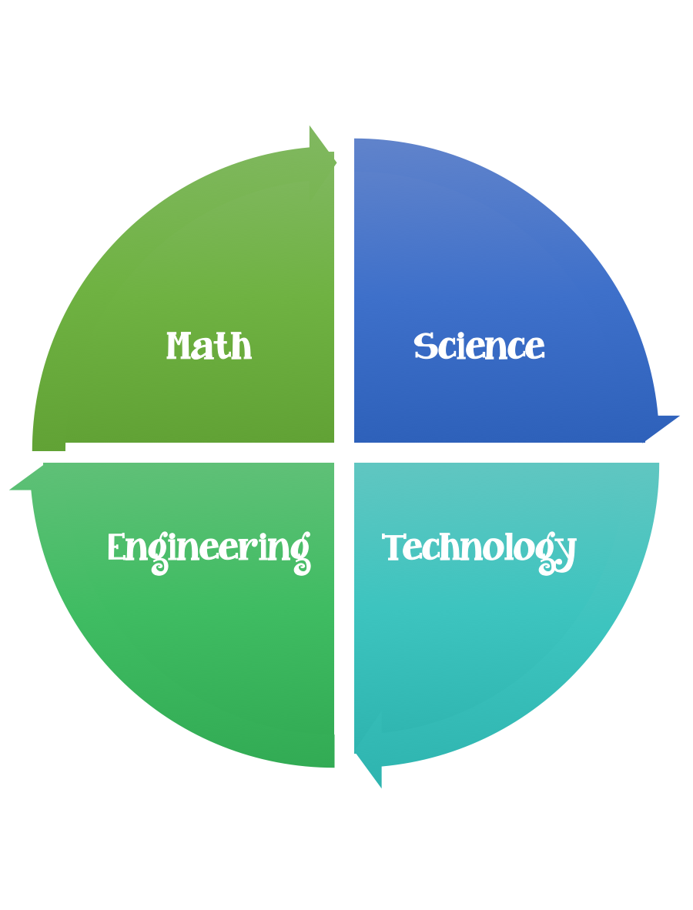
Findley Oaks STEM Connect
1st Grade Design Brief

Month  March | Challenge  Butterflies are Free | Unit  Animals
Standard:
Students should follow the engineering design process.
Background/Problem: Read the story Olmo and the Blue Butterfly. Olmo followed the blue butterfly many places.
Design Challenge: Design and make your own blue butterfly.

Criteria:
Your butterfly must:
- be blue.
- have matching wings.
- have antennae.

Constraints: You can only use the materials provided. Everyone in your group needs to participate.
Materials: (per group of 2)
one piece of blue construction paper
pom–poms
ribbon
glue and/or glue sticks

pipe cleaners
anything from the scrap box
brads (only to make something move or to connect parts)
1 toilet paper role
google eyes
Anything else your teacher puts out for you to use

Tools:
markers and / or crayons
scissors
crazy scissors
hole punch
staplers
rulers

Paper (For design planning)
Pencils

