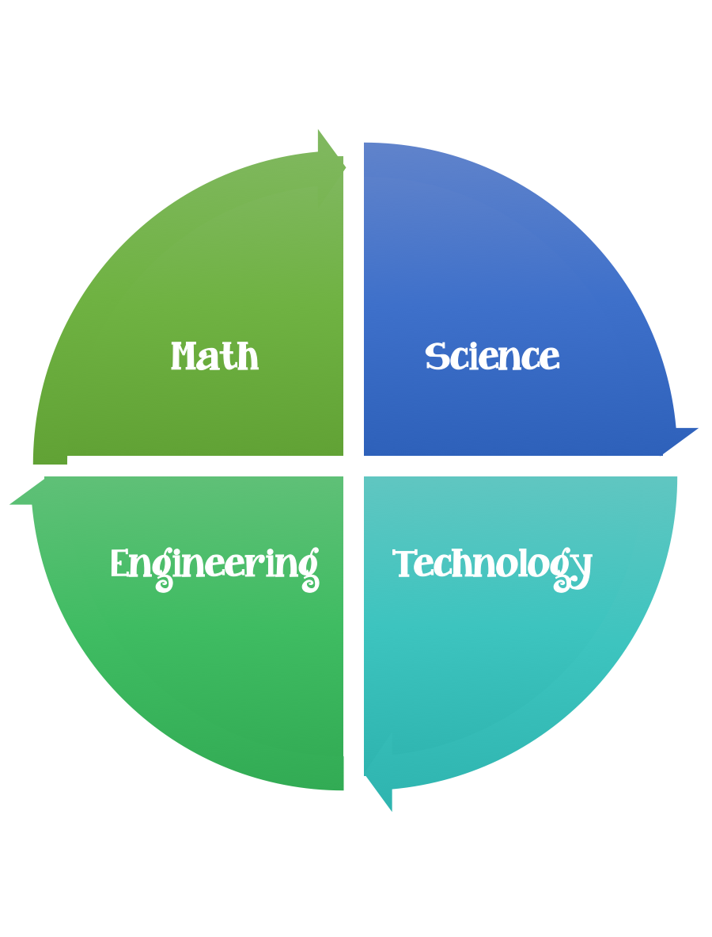
Findley Oaks STEM Connect
1st Grade Design Brief

Month  October | Challenge  Magnet Maze | Unit  Magnets
Standard:
Students should follow the engineering design process.
Background/Problem: During our study of magnets we’ve learned how they attract and repel, have a north and south pole and a magnetic field. We’ve learned which kinds of materials are magnetic.
Design Challenge: Use what we’ve learned about magnets to design and construct a magnetic maze and be able to guide an object through the maze using a magnet.
Criteria:
Your project must:
- Have a clear start and finish
- Be neat and colorful
- Include an object that is magnetic
- Include your signature on the outside of the maze

Constraints: You can only use the materials provided.

Materials: per student
- Things that are round - paper plates – different sizes – cardboard that could be cut into circles. Give students choices to select from.
- Templates/some students may be able to design a maze without a template.
- Magnets 2 each
- Cardstock
Tools:
Markers and / or crayons
Scissors

Paper (For design planning)
Pencils
Examples: Students should create their maze connect puzzles.
Dog – doghouse/bone
Bird – birdhouse
Bee – beehive
Penguin – igloo
Cat - mouse
Rabbit – carrot
Rocket ship - moon

