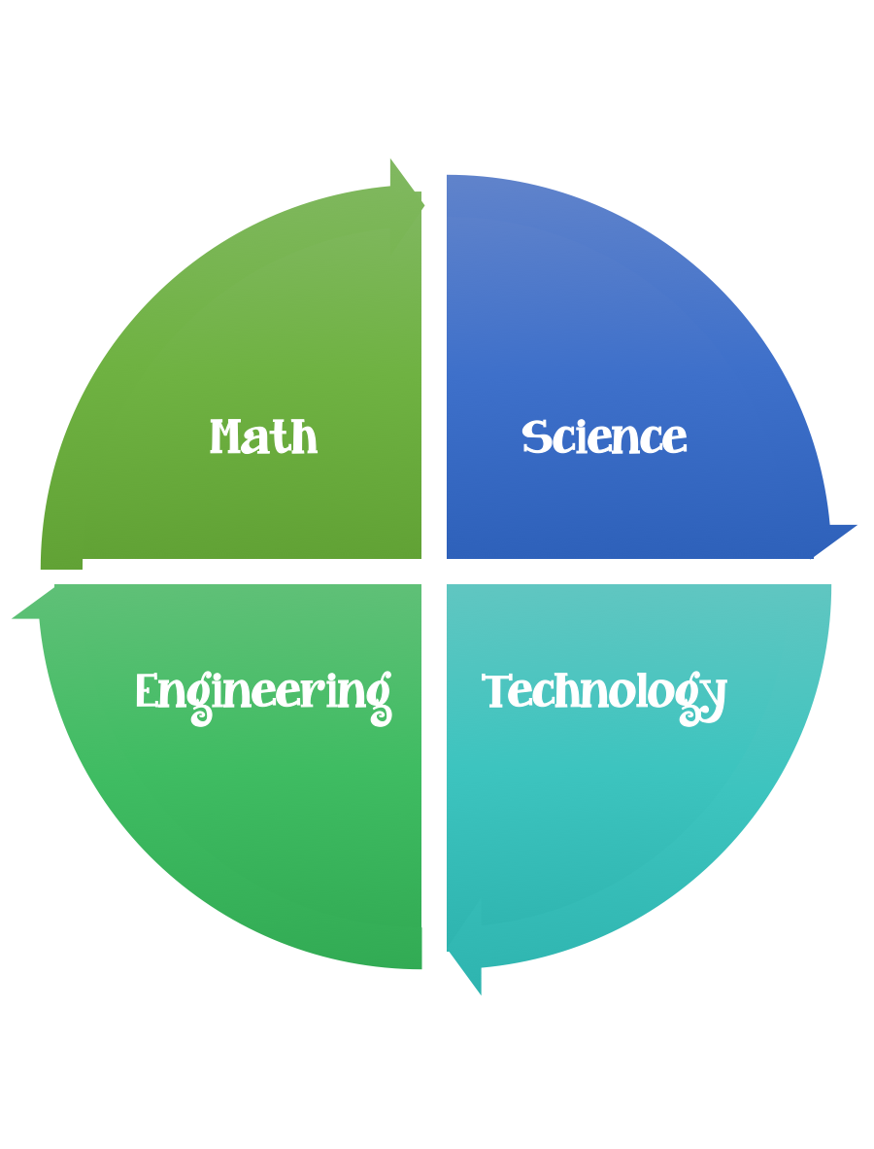
Findley Oaks STEM Connect
4th Grade Design Brief

Month  August | Challenge  Water Cycle Design Challenge | Unit  States of Water and the Water Cycle
Standard:
Students should follow the Engineering Design Process.
Background/Problem: We have been studying about the water cycle. We have learned about the properties of water and the many ways that we use water. This week our focus is on the water cycle. We need to design a triorama illustrating how the water cycle works to share with others.
Design Challenge: Your challenge is to design a triorama illustrating how the water cycle works. Please include the provided labels. Your triorama should also include one moving part or a pop up. You will share your water cycle triorama with the class.
Criteria: Your triorama must:
- include one movable part or one pop-up.
- include the provided labels.
- evaporation, condensation, precipitation, run off
- show how each part of the water cycle works
Constraints:
You must work with a partner (or in a group of 3) teacher discretion.
Make sure you have a design plan before you start.
You may use some or all of the materials listed.

Materials: (per team or group) 2,3 (teacher discretion)
- White construction paper 12 X18 for folding triorama
- Scrap box materials
- Glue
- Paper fasteners

Tools:
- Scissors
- Crazy scissors
- Staplers
- Hole punch
- Rulers

Paper/pencil for design planning

Options: Brainstorm ideas…. make sure the students have time to plan.

evaporation

condensation

precipitation

__________________________________________________________
run off

