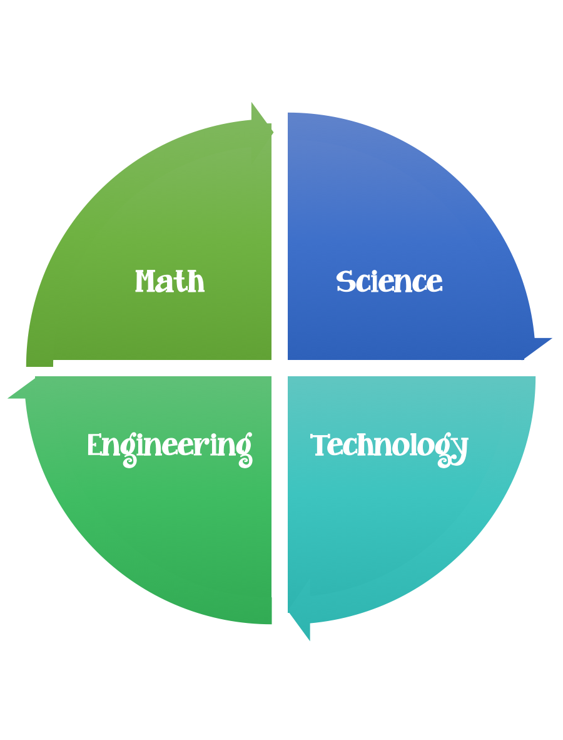
Findley Oaks STEM Connect
4th Grade Design Brief

Month  October | Make a Comet | Unit  Stars, Star Patterns, and Planets
Standard:
Students should follow the Engineering Design Process.
Background/Problem: NASA needs to follow the path of a comet as it makes its way through space while simulating the heat and gravitational effects of the Sun.
Design Challenge: Your challenge is to design a comet. Simulate movement of the comet through the solar system, carry the comet as you walk around a bright bulb (the sun) in a darkened room. Far from the bulb walk very slowly, and comment on the low temperature and feeble light. Closer to the bulb, describe passing Saturn and Jupiter, and near Mars warming up so the tail begins to form. Walk more quickly towards the bulb (the increasing gravitational pull between the sun and the comet causes it to move faster) swing around it, and head away tumbling the comet as you go.
Criteria:
1. Line a mixing bowl with a plastic liner.
2. Add sand, ammonia and corn syrup.
3. Place dry ice in 3 garbage bags that have been placed inside each other.
4. Crush Ice by pounding it with a hammer.

5. Add the dry ice to the rest of the ingredients in the mixing bowl while stirring vigorously.

6. Continue stirring until the mixture is almost totally frozen.
7. Lift the comet out of the bowl using the plastic liner and shape it as you would a snowball.
8. Unwrap the comet as soon as it is frozen sufficiently to hold its shape

Constraints:
You must work with a partner (or in a group of 3) teacher discretion.
Make sure you have a design plan before you start.
You may use some or all of the materials listed.

Materials: (per team or group) 2,3, or 4 (teacher discretion)
- Dry Ice
- Garbage Bags
- Hammer
- Gloves
- Ice-cream sticks
- Sand or Dirt
- Ammonia
- Corn syrup

Tools:
- Scissors
- Crazy scissors
- Staplers
- Hole punch
- Rulers
- Hammers

Paper/pencil for design planning

Options: Brainstorm ideas…. make sure the students have time to plan.

What's happening?
The comet will start to melt turning directly from a solid to a gas (which is what carbon dioxide does at room temperature and comets do under the conditions of interplanetary space when they are heated by the sun).
For safety the children can use ice-cream sticks to examine the comet. As it begins to melt they may notice small jets of gas coming from it. These are locations where the gaseous carbon dioxide is escaping through small holes in the still frozen water. This is also detected on real comets, where the jets can sometimes expel sufficient quantities of gas to make small changes in the orbit of the comet.
After several hours the comet will become a crater-filled ice ball as the more volatile carbon dioxide sublimated before the water ice melts. Real comets are also depleted by sublimation each time they come near the Sun. Ultimately, old comets may break into several pieces or even completely disintegrate. In some cases, the comet may have a solid, rocky core that is then left to travel around the comet's orbit as a dark barren asteroid.

