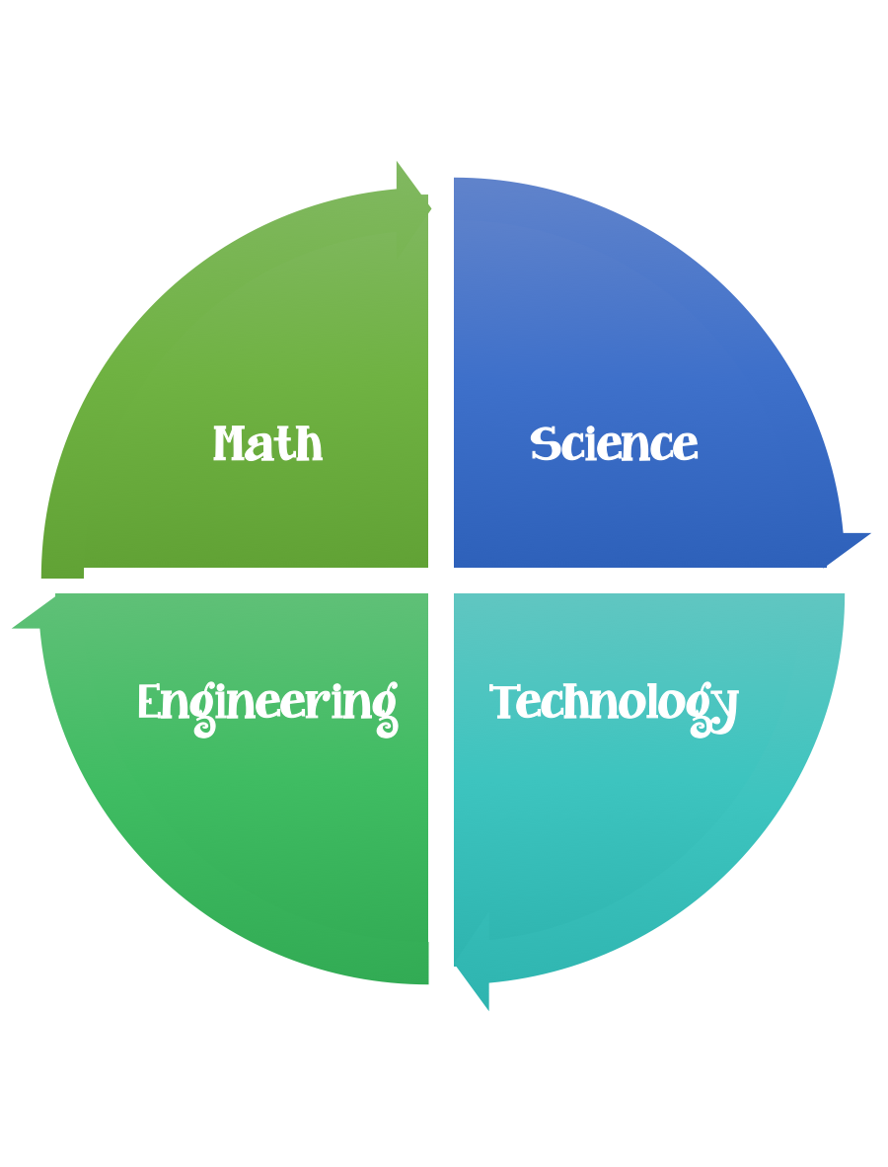
Fulton County STEM Connect
Kindergarten Design Brief

Month  October | Challenge  Marble Maze | Unit  Gravity
Standard:
Students should follow the engineering design process.
Background/Problem: Six Flags has a lot of roller coasters. Why do they travel at different speeds depending on the direction they are going? Can you help design a faster roller coaster?
Design Challenge: Students will create a maze for a marble. They should brainstorm a design plan before they start/glue.
Criteria: Your marble must travel only by tilting the box top.
Your maze should have a starting point and a stopping point.
Your maze needs to have at least four turns in it.
Your straws should be at least two different lengths. (Advanced students may be able to measure the lengths, 4,6,8, and 10 centimeters.)

Constraints: You can only use the materials provided. If your marble falls out of the box you need to restart.

Options: Test your maze three times by setting a timer. What is your fastest time? Decorate your maze with paint, markers, or crayons.

Materials: (per student or team )
Shoe box top or any other top with sides
6-10 straws
1 marble

Tools:
Glue
Tape
Scissors
Rulers
Pencil
Paper

Optional:
Markers
Paint
Crayons

