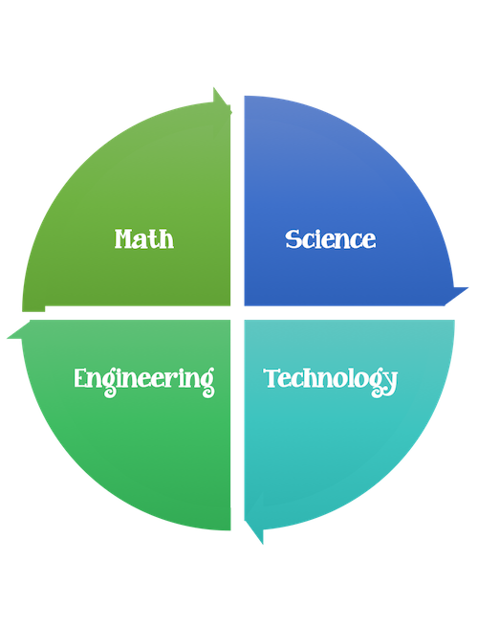
My STEM Notebook

Name ____________________________

Teacher ____________________________

Grade __________

